Name______________________________ Date_______________________

Mitosis - Cell Division

# Microscope Slides

## You are required to carefully analyze the cell displayed on the computer screen. These pictures are genuine microscopic images captured (not an artistic rendering). Carefully observe these cells and record your observations.

**Guidelines for Observations:** What type of cell is this – Plant or Animal? What stage of cell cycle is this cell currently in? What events or objects led to your decision? Can you recognize any specific organelles (if so – which ones)? What is occurring in this cell?

**Label each cell as accurately as possible.**

**Slide #1**: Plant or Animal?___________ Stage of the Cell Cycle?___________

[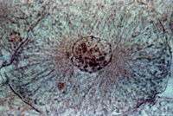](http://biog-101-104.bio.cornell.edu/biog101_104/tutorials/cell_division/wf_review.html)Observations:_______________________________

__________________________________________

__________________________________________

__________________________________________

__________________________________________

__________________________________________

__________________________________________

**Slide #2**: Plant or Animal?___________ Stage of the Cell Cycle?___________

[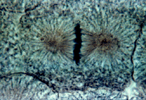](http://biog-101-104.bio.cornell.edu/biog101_104/tutorials/cell_division/wf_review.html)Observations:_______________________________

__________________________________________

__________________________________________

__________________________________________

__________________________________________

__________________________________________

__________________________________________

**Slide #3**: Plant or Animal?___________ Stage of the Cell Cycle?___________

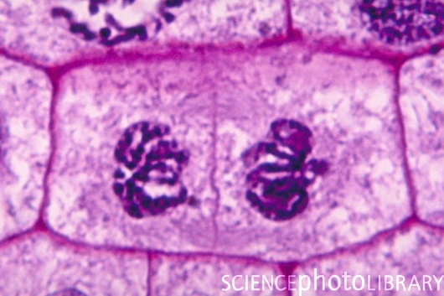Observations:_______________________________

__________________________________________

__________________________________________

__________________________________________

__________________________________________

__________________________________________

__________________________________________

**Slide #4**: Plant or Animal?___________ Stage of Cell Cycle?___________

[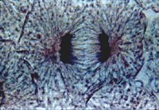](http://biog-101-104.bio.cornell.edu/biog101_104/tutorials/cell_division/wf_review.html)Observations:_______________________________

__________________________________________

__________________________________________

__________________________________________

__________________________________________

__________________________________________

__________________________________________