CP Biology NAME Date Period

Virtual Foods Lab – Testing for Organic Nutrients

For this activity we will use this website http://faculty.kirkwood.edu/apeterk/learningobjects/biologylabs.htm

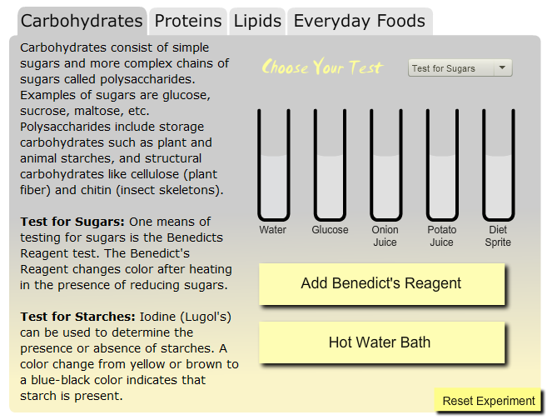
CARBOHYDRATES
Scroll down to the bottom and click on Carbohydrate

- What do carbohydrates consist of?
simple sugars and more complex chains
of sugars called polysaccharides.

- How do you test for sugars? (How does it work?)
One means of testing for sugars is the Benedicts Reagent test. The Benedict's Reagent changes color after heating in the presence of reducing sugars.

Click on Add Benedict’s Reagent, then click on Hot Water Bath

Complete the virtual test for sugar and record your results below. The first two have been done for you.
 | Benedict’s Reagent | Hot Water Bath | Sugar (yes/no)
Water | Light blue | Light Blue | No
Glucose | Light Blue | Medium Red Orange | Yes
Onion Juice | Light Blue | Yellow | Yes
Potato Juice | Blueish Green | Green | Yes
Diet Sprite | Light Blue | Light Blue | No


Test for Starches:

Click on the menu and choose “Test for Starches”

1. What is used to detect the presence or absence of starches? Iodine (Lugol’s)
2. What is the expected color change? A color change from yellow or brown to a blue-black color indicates that starch is present.

Click on Add Iodine.

Complete the virtual test and record the color changes under the Iodine column. Then indicate whether there is starch present in the foods.
 | Iodine | Starch (yes/no)
Water | Light yellow | No
Starch | Blue-black | Yes
Onion Juice | Light yellow | No
Potato Juice | Dark blue-black | Yes
Diet Sprite | Medium Yellow | No


PROTEINS

Click on the tab marked protein
- What are the chains that make up proteins? Amino acids

Click on Add Biuret Reagent
- What does a positive result look like? Purple

Complete the virtual test and record the color changes under the Biuret. Then indicate if there is protein present in the foods.
 | Biuret (color) | Protein (yes/no)
Water | Light blue | No
Egg White | Purple | Yes
Chicken Soup | Purple | Yes
Diet Sprite | Light Blue | No

Test for Lipids:
1. The indicator for lipids is Iodine (Lugol’s)

2. The expected color change for a positive lipid test is a vivid orange color should appear

Complete the virtual test and record the color changes under the Sudan II (dye intensity/color). Then indicate if there is lipids present in the foods.
 | Sudan III (dye intensity/color) | Lipid (yes/no)
Water | No color change (dark gray) | No
Cream | Vivid Orange | Yes
Coconut | Vivid Orange | Yes
Egg White | No color change (dark gray) | No
Margarine | Vivid Orange | Yes

EVERYDAY FOODS

Click on the tab marked “Everyday Foods” and use the pull down menu on the top right.

Complete the data table below to record the test results.
 | Benedict’s Reagent and Hot Water Bath | Iodine Test | Biuret Test | Sudan III
Gelatin | Blue | Dark gray | Purple | No color change
Apple Juice | Green→Orange | Dark gray | Dark gray | No color change
Ritz Cracker | Green→Blue | Grayish black | Light blue | Vivid Orange
Skim Milk | Green→Orange | Whitish | Purple | Vivid Orange

Which of the above foods contain glucose? Apple juice, ritz cracker and skim milk

Which of the above foods contain starch? Ritz cracker

Which of the above foods contain protein? Gelatin, skim milk

Which of the above foods contain lipid? Ritz cracker, skim milk

