1. Monopolistic competition means:

A) a market situation where competition is based entirely on product differentiation and advertising.

B) a large number of firms producing a standardized or homogeneous product.

C) many firms producing differentiated products.

D) a few firms producing a standardized or homogeneous product.

Answer: C

3. Under monopolistic competition entry to the industry is:

A) completely free of barriers.

B) more difficult than under pure competition but not nearly as difficult as under pure monopoly.

C) more difficult than under pure monopoly.

D) blocked.

Answer: B

4. Monopolistic competition resembles pure competition because:

A) both industries emphasize nonprice competition.

B) in both instances firms will operate at the minimum point on their long-run average total cost curves.

C) both industries entail the production of differentiated products.

D) barriers to entry are either weak or nonexistent.

Answer: D

8. The restaurant, legal assistance, and clothing industries are each illustrations of:

A) countervailing power.

B) homogeneous oligopoly.

C) monopolistic competition.

D) pure monopoly.

Answer: C

15. Monopolistically competitive and purely competitive industries are similar in that:

A) both are assured of short-run economic profits.

B) both produce differentiated products.

C) the demand curves facing individual firms are perfectly elastic in both industries.

D) there are few, if any, barriers to entry.

Answer: D

31. In the long-run, the price charged by a monopolistically competitive firm seeking to maximize profit will:

A) be less than both MC and ATC.

B) exceed ATC, but equal MC.

C) exceed MC, but equal ATC.

D) exceed both MC and ATC.

Answer: C

33. In the long-run, economic theory predicts that a monopolistically competitive firm will:

A) earn an economic profit.

B) realize all economies of scale.

C) equate price and marginal cost.

D) have excess production capacity.

Answer: D

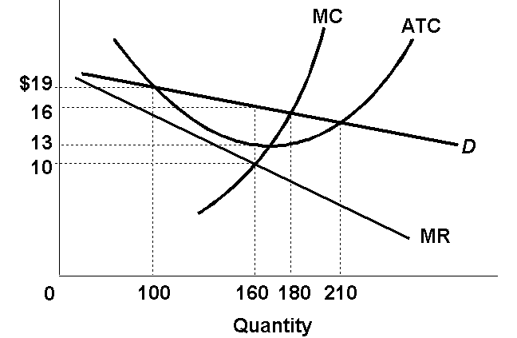

35. Refer to the above diagram for a monopolistically competitive firm in short-run equilibrium. This firm's profit-maximizing price will be:

A) $10.

B) $13.

C) $16.

D) $19.

Answer: C

Type: Graphical Topic: 3 LO: 23-1 ECON: 447 MICRO: 213

36. Refer to the above diagram for a monopolistically competitive firm in short-run equilibrium. The profit-maximizing output for this firm will be:

A) 210.

B) 180.

C) 160.

D) 100.

Answer: C

37. Refer to the above diagram for a monopolistically competitive firm in short-run equilibrium. This firm will realize an economic:

A) loss of $320.

B) loss of $480.

C) profit of $280.

D) profit of $600.

Answer: B

39. In the short run a monopolistically competitive firm's economic profit:

A) will be maximized where price equals average total cost.

B) may be positive, zero, or negative.

C) are always positive.

D) will always be zero.

Answer: B

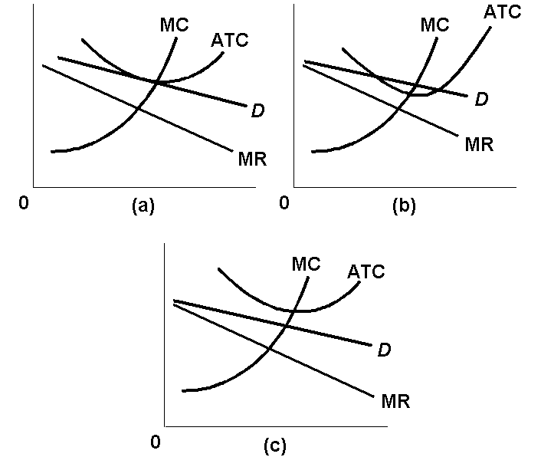

46. Refer to the above diagrams, which pertain to monopolistically competitive firms. Short-run equilibrium entailing economic loss is shown by:

A) diagram *a* only.

B) diagram *b* only.

C) diagram *c* only.

D) both diagrams a and *c*.

Answer: C

47. Refer to the above diagrams, which pertain to monopolistically competitive firms. A short-run equilibrium entailing economic profits is shown by:

A) diagram *a* only.

B) diagram *b* only.

C) diagram *c* only.

D) both diagrams *b* and *c*.

Answer: B

Type: Graphical Topic: 3 LO: 23-2 ECON: 447 MICRO: 213

48. Refer to the above diagrams, which pertain to monopolistically competitive firms. Long-run equilibrium is shown by:

A) diagram *a* only.

B) diagram *b* only.

C) diagram *c* only.

D) both diagrams *b* and *c*.

Answer: A

56. When a monopolistically competitive firm is in long-run equilibrium:

A) production takes place where ATC is minimized.

B) marginal revenue equals marginal cost and price equals average total cost.

C) normal profit is zero and price equals marginal cost.

D) economic profit is zero and price equals marginal cost.

Answer: B

58. If some firms leave a monopolistically competitive industry, the demand curves of the remaining firms will:

A) be unaffected.

B) shift to the left.

C) become more elastic.

D) shift to the right.

Answer: D

59. When a monopolistically competitive firm is in long-run equilibrium:

A) *P* = MC = ATC.

B) MR = MC and minimum ATC > *P*.

C) MR > MC and *P* = minimum ATC.

D) MR = MC and *P* > minimum ATC.

Answer: D

60. Other things equal, if more firms enter a monopolistically competitive industry:

A) the demand curves facing existing firms would shift to the right.

B) the demand curves facing existing firms would shift to the left.

C) the demand curves facing existing firms would become less elastic.

D) losses would necessarily occur.

Answer: B

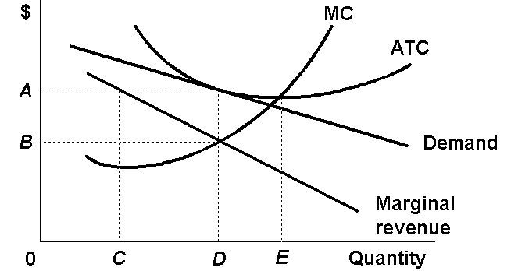

Type: Graphical Topic: 3 LO: 23-2 ECON: 447 MICRO: 213

75. Refer to the above diagram for a monopolistically competitive producer. The firm is:

A) minimizing losses in the long run.

B) minimizing losses in the short run.

C) realizing a normal profit in the long run.

D) about to leave the industry.

Answer: C

Type: Graphical Topic: 3 LO: 23-1 ECON: 447-449 MICRO: 213-215

76. Refer to the above diagram for a monopolistically competitive producer. This firm is experiencing:

A) a shortage of production capacity.

B) excess capacity of *CD*.

C) excess capacity of *DE*.

D) diseconomies of scale.

Answer: C

Type: Graphical Topic: 3 LO: 23-1 ECON: 449 MICRO: 215

77. Refer to the above diagram for a monopolistically competitive producer. If this firm were to realize productive efficiency, it would:

A) also realize an economic profit.

B) incur a loss.

C) also achieve allocative efficiency.

D) have to produce a smaller output.

Answer: B

119. Industries X and Y both have four-firm concentration ratios of 65 percent, but the Herfindahl index for X is 1,500 while that for Y is 2,000. These data suggest:

A) greater market power in X than in Y.

B) greater market power in Y than in X.

C) that X is more technologically progressive than Y.

D) that price competition is stronger in Y than in X.

Answer: B

127. If you sum the squares of the market shares of each firm in an industry (as measured by percent of industry sales), you are calculating:

A) the four-firm concentration ratio.

B) the Herfindahl index.

C) the degree of collusion.

D) the Lerner index.

Answer: B



Type: Table Topic: 6 LO: 23-3 ECON: 452 MICRO: 218

133. Refer to the above data. The four-firm concentration ratio for the above industry is:

A) 100 percent.

B) indeterminate, since we don't know which four firms are included.

C) 80 percent.

D) 20 percent.

Answer: C

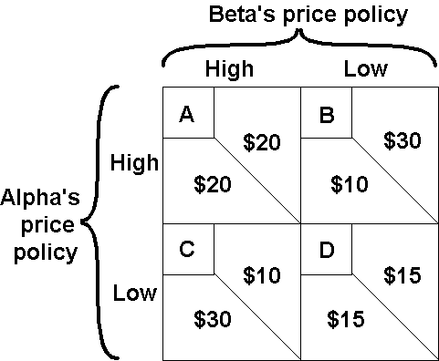

148. Refer to the above diagram wherein the numerical data show profits in millions of dollars. Beta's profits are shown in the northeast corner and Alpha's profits in the southwest corner of each cell. If Beta commits to a high-price policy, Alpha will gain the largest profit by:

A) also adopting a high-price policy.

B) adopting a low-price policy.

C) adopting a low-price policy, but only if Beta agrees to do the same.

D) engaging in non-price competition only.

Answer: B

Type: Table Topic: 7 LO: 23-4 ECON: 453 MICRO: 219

149. Refer to the above diagram where the numerical data show profits in millions of dollars. Beta's profits are shown in the northeast corner and Alpha's profits in the southwest corner of each cell. With independent pricing the outcome of this duopoly game will gravitate to cell:

A) A.

B) B.

C) C.

D) D.

Answer: D

Type: Table Topic: 7 LO: 23-4 ECON: 453 MICRO: 219

150. Refer to the above diagram where the numerical data show profits in millions of dollars. Beta's profits are shown in the northeast corner and Alpha's profits in the southwest corner of each cell. If Alpha and Beta engage in collusion, the outcome of the game will be at cell:

A) A.

B) B.

C) C.

D) D.

Answer: A



156. Refer to the above game theory matrix where the numerical data show the profits resulting from alternative combinations of advertising strategies for Ajax and Acme. Ajax's profits are shown in the upper right part of each cell; Acme's profits are shown in the lower left. With collusion and no cheating, the outcome of the game is cell:

A) A.

B) B.

C) C.

D) D.

Answer: D

178. Oligopolistic firms engage in collusion to:

A) minimize unit costs of production.

B) realize allocative efficiency, that is, the *P* = MC level of output.

C) earn greater profits.

D) increase production.

Answer: C

182. If the firms in an oligopolistic industry can establish an effective cartel, the resulting output and price will approximate those of:

A) a purely competitive producer.

B) a pure monopoly.

C) a monopolistically competitive producer.

D) an industry with a low four-firm concentration ratio.

Answer: B

185. One would expect that collusion among oligopolistic producers would be easiest to achieve in which of the following cases?

A) a rather large number of firms producing a differentiated product

B) a very small number of firms producing a differentiated product

C) a rather large number of firms producing a homogeneous product

D) a very small number of firms producing a homogeneous product

Answer: D

186. Suppose the only three existing manufacturers of video game players signed a written contract by which each agreed to charge the same price for products and to distribute their products only in the geographical area assigned them in the contract. This best describes:

A) cost-plus pricing.

B) multiproduct pricing.

C) a cartel.

D) price leadership.

Answer: C

191. A break-down in price leadership leading to successive rounds of price cuts is known as:

A) limit pricing.

B) a price war.

C) tacit pricing

D) price discrimination

Answer: B

196. Advertising can enhance economic efficiency when it:

A) increases brand loyalty.

B) raises entry barriers.

C) increases consumer awareness of substitute products.

D) boosts average total cost.

Answer: C

Type: Application of Concept Topic: 10 LO: 23-7 ECON: 461 MICRO: 227

197. Advertising can enhance economic efficiency when it:

A) increases brand loyalty.

B) expands sales such that firms achieve substantial economies of scale.

C) keeps new firms from entering profitable industries.

D) is undertaken by pure competitors.

Answer: B

Type: Application of Concept Topic: 10 LO: 23-7 ECON: 462 MICRO: 228

198. Advertising can impede economic efficiency when it:

A) increases entry barriers.

B) reduces brand loyalty.

C) enables firms to achieve substantial economies of scale.

D) increases consumer awareness of substitute products.

Answer: A

201. We would expect a cartel to achieve:

A) both allocative efficiency and productive efficiency.

B) allocative efficiency, but not productive efficiency.

C) productive efficiency, but not allocative efficiency.

D) neither allocative efficiency nor productive efficiency.

Answer: D

204. The conclusion that oligopoly is inefficient relative to the competitive ideal must be qualified because:

A) industry price leaders often select a price equal to marginal cost.

B) over time oligopolistic industries may promote more rapid product development and greater improvement of production techniques than if they were purely competitive.

C) increased output due to persuasive advertising may perfectly offset the restriction of output caused by monopoly power.

D) many oligopolists sell their products in monopolistically competitive or even purely competitive industries.

Answer: B