**HOW TO BE COMFY AT THE KEYBOARD**

Typing away at a computer may not look like an activity that could cause much physical damage. But gazing at a monitor for hours, pounding a keyboard thousands of time, sitting hunched over a desk all day—these stresses can cause fatigue, and in some cases, even long-term debilitating injury.

This is where it is important to introduce *ergonomics*—the science of fitting the job to the worker. Researchers now know the position, lighting, technique, and routine that can help computer users avoid injury. Follow these tips for safe keyboarding:

* **Adjust the height of your chair and desk** so forearms are parallel with the floor and wrists are level with the keyboard.
* **Keep your wrists straight and aligned with your forearms**—don’t bend them sideways or arch your fingers up to hit the keys. Don’t type with your wrists resting on the desktop.
* **Don’t look up at the screen**. The top of the monitor should be no higher than eye level.
* **Avoid glare and reflection on the screen**. Use curtains or shades, or reposition the monitor at a better angle.
* **Posture counts**. Sit upright with your feet on the floor.
* **Take breaks**. Looking away from the monitor for a couple of seconds every few minutes can help prevent eyestrain. Stand up and stretch periodically.

**TIPS TO KEEP YOUR EYES, FINGERS, WRISTS, AND BACK HEALTHY AND PAIN-FREE.**

**RIGHTS AND WRONGS**

Small changes to the position of your hands and wrists can make a big difference in your comfort at the keyboard and also prevent injury.

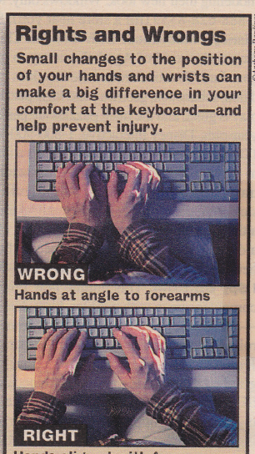

Hands at angle to forearms



Hands aligned with forearms

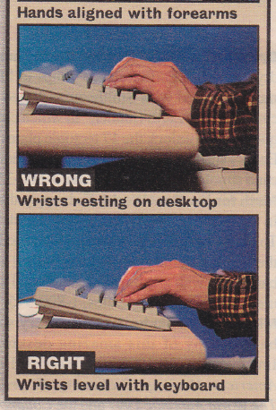

Wrists resting on desktop



Wrists level with keyboard

Source: Morgenstern, Steve. “How To Be Comfy At The Keyboard.” Parade Magazine.