- What steps did Qin Shi Huang Di take to unify China?
  - Conquered all rival states by 221 BCE
  - Ended feudalism
  - Created Bureaucracy CONNECTION = AUGUSTUS
    - Divided into 36 commanderies (“states”)
      - Civil Governor – laws and agriculture
      - Military Governor – armies
      - Imperial Overseer – supervised the two other governors and informed emperor directly
  - Took weapons of enemies
  - Had feudal lords and their families move to capital to keep watch over them (keep your friends close and you enemies closer)

- What aspects of Chinese culture did Qin Shi Huang Di standardize?
  - Standardized writing system
    - Eliminated ¼ characters
    - Writers could only use government approved characters
    - Result - Improved communication throughout empire
  - Standardized measurements
    - All measuring cups same size
  - Standardized coinage and money - could use same money throughout empire CONNECTION = ROME

- How did Shi Huang Di maintain order?
  - Vast, unified system of laws CONNECTION = 12 Tables, Justinian Code
    - Detailed laws which regulated life for officials and everyday citizens
    - Legalist – harsh and swift punishments
    - Everyone punished or treated equally under law
  - Roads CONNECTION = Roman Roads
    - Linked far away places with capital
    - Toured empire to make sure laws were being followed
    - Erected pillars with imperial edicts to praise emperor

- Why was there conflict between Qin Shi Huang Di and Confucian scholars? What did he do to those that disagreed with him?

- Scholars were Confucian and Shi Huang Di was Legalist
  - Disagreed with Confucian scholars emphasis on past traditions
- Attacked Confucian scholars CONNECTION = Nero blamed Christians
  - Burned books
  - Facial tattoos
  - Executions - beheaded
  - Buried alive
  - Sent to work on Great Wall

- Why did Qin Shi Huang Di force his subjects to build an enormous wall in northern China? Why is the Great Wall often referred to as “the longest graveyard in the world?”

  - Wanted to keep out invading people from North Central Asia
  - Discourage people from leaving empire
  - Many thousands of people died building the Great Wall
  - CONNECTION = Hadrian’s Wall

- What is unique about the death and burial of Qin Shi Huang Di?

  - Wanted to live forever
  - Maybe poisoned himself looking for potions to achieve immortality
  - Started his tomb at age 13
  - 700,000 workers – many buried alive to keep location and treasures a secret
  - Underground city filled with rare jewels
  - Terra cotta soldiers – entire army of thousands of clay soldiers to lead emperor into next world

Name: _____________________________________ Date: ____________ Period: ___________ Page: _________
QIN EMPIRE: SHI HUANG DI
Directions: For each of the following questions, provide four points to answer the question. Make sure you explain each point.
- What steps did Qin Shi Huang Di take to unify China?

- What aspects of Chinese culture did Qin Shi Huang Di standardize?

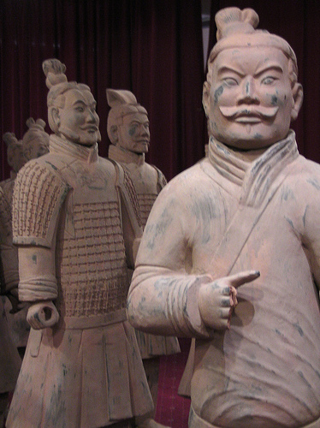
- How did Shi Huang Di maintain order?

- Why was there conflict between Qin Shi Huang Di and Confucian scholars? What did he do to those that disagreed with him?

- Why did Qin Shi Huang Di force his subjects to build an enormous wall in northern China? ? Why is the Great Wall often referred to as “the longest graveyard in the world?”

- What is unique about the death and burial of Qin Shi Huang Di?

