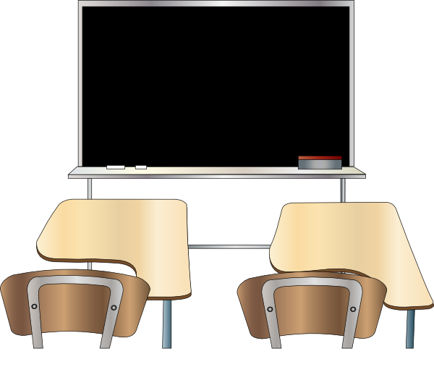
Realidades 2B
Nombre:___________________
Hora:_____________
Vocabulario: Realidades 2B

_______________________________________________________
_______________________________________________________
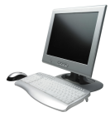 _______________________________________________________
_______________________________________________________
_______________________________________________________
_______________________________________________________

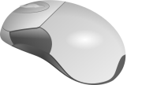 _______________________________________________________
_______________________________________________________
_______________________________________________________
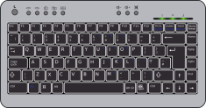 _______________________________________________________
_______________________________________________________
_______________________________________________________
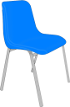 _______________________________________________________
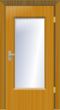 _______________________________________________________

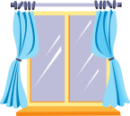 _______________________________________________________

To talk about location:
al lado de la/al lado del
allí
aquí
debajo de la/debajo del
delante de la/delante del
detrás de la/detrás del
¿Dónde?
en
encima de la/encima del

To indicate possession:
de
mi
tu
To identify (description/quantity):
es un(a)…
hay
¿Qué es esto?

Forms of estar:

To identify gender & quantity of nouns:
los, las
unos, unas

Actividades con Vocabulario

Activity 1: Sit next to a partner, and put just one person’s packet between you two. As your teacher calls the Spanish terms, try to be the first to find the picture/English term. If you point at it first, write down a tally mark in the margin.

Activity 2: Next, with the same partner, play the dot game! The first person says the Spanish of two pictures/terms that are either side-by-side or one above the other, and that person draws a line connecting those two. Keep taking turns saying the Spanish and drawing lines. If you ever draw the fourth line to complete a square, write your initials in the box!

 |  |  | 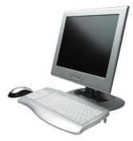
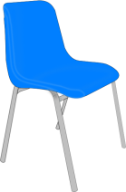 | 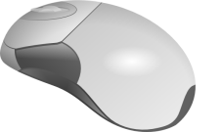 | 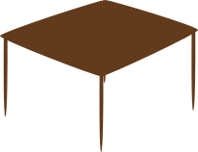
 | 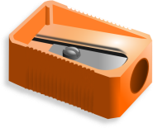 |  | 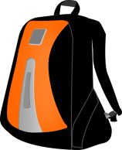
 |  | 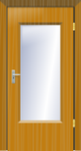 | next to
here | there | underneath | in front of
behind | Where? | in, on | on top of

del=of the (masculine), de la=of the (feminine)
Try saying “de el” slowly, and then saying it quickly. Notice that when you say these two words together quickly, they sound like “del.” In Spanish, we always combine these two words to make “del” in both writing and speaking. “De” and “la” stay as two separate words.

of the table= _________________________
of the desk= _________________________
of the backpack=______________________
of the mouse=________________________
of the screen=________________________
of the computer=_____________________
of the keyboard=______________________
of the door=_________________________

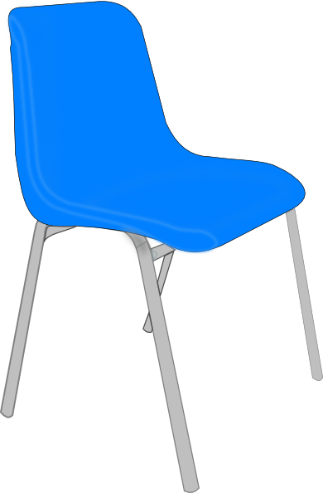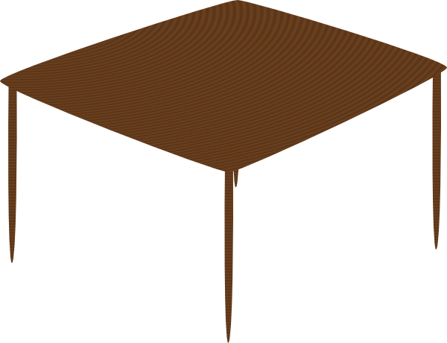
Frases completes (use está for is):
1. The computer is on top of the desk.
_____________________________________________________________________________

2. Your chair is behind the table.
_____________________________________________________________________________

3. The mouse is next to the keyboard.
_____________________________________________________________________________

4. My homework is underneath the notebook.
_____________________________________________________________________________

¿Cierto o falso?
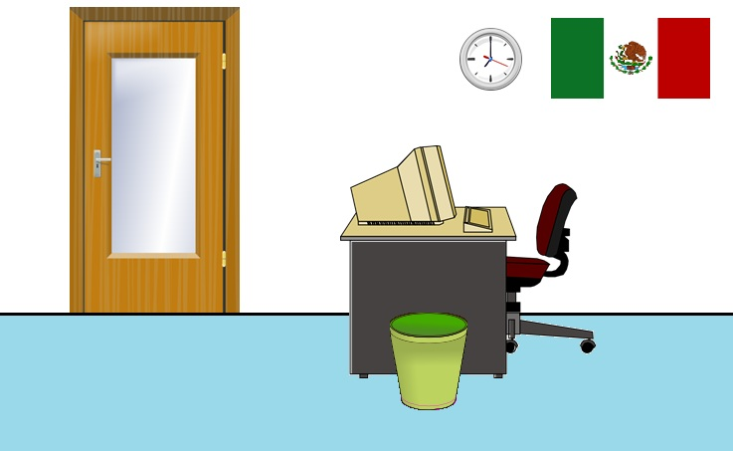

Escribe cierto o falso:
_________________ 1. El reloj está al lado de la bandera.
_________________2. El teclado está debajo del escritorio.
Vocabulario importante:
al lado de=
debajo de=
delante de=
detrás de=
encima de=
_________________3. La computadora está encima del escritorio.
_________________4. La papelera está debajo de la puerta.
_________________5. La silla está detrás de la puerta.
_________________6. El escritorio está debajo del reloj.
_________________7. El escritorio está detrás de la papelera.
_________________8. La puerta está debajo de la papelera.
_________________9. La silla está debajo de la bandera.
_________________10. La papelera está al lado del reloj.
Artículos indefinidos y definidos

el, la, los, las = definite articles (“the”)
un, una = indefinite articles (“a,” “an”)
unos, unas = indefinite articles (“some”)

the flag= _____ _________________ the flags= _____ ___________________
a flag= _____ ___________________ some flags= ______ ___________________
the desk= _____ _________________ the desks= _____ ___________________
a desk= _____ ___________________ some desks= ______ __________________

Remember, to make a noun plural that ends with a consonant, add “es.” If it ends with a z, change the z to a c and then add “es.”
the clock= _____ _________________ the clocks= _____ ___________________
a clock= _____ ___________________ some clocks= ______ _________________
the pencil= _____ _________________ the pencils= _____ ___________________
a pencil= _____ ___________________ some pencils= ______ _________________
Buscapalabras (Word Search)
l a s m o c h i l a s d e l a m e s a
y e n i s r w s e l e t r a c s o n u
e l s a c a p u n t a s a o m y x f b
s a n a t n e v s a l t a j h g x o f
u n a p a p e l e r a n ó t a r u t a
h t z b g l o s r e l o j e s q f g s
o t s e s e é u q o d a l c e t l e d
u n a s c o m p u t a d o r a s q i o
s o i r o t i r c s e s o n u y z q w
m i c o m p u t a d o r a m y b z l n
s a r e d n a b s a n u l s p d h j k

Translate these phrases into Spanish, and then find the Spanish translations in the word search above.

some desks
some posters
the backpacks
some computers
of the table
of the keyboard
the pencil sharpener

What is this?
some flags
the windows
a wastepaper basket
my computer
the clocks
your mouse
Estar = to be
I am = | we are=
you (informal) are= | you all are (when in Spain)=
he is=  she is=  you (formal) are= | they (masculine) are=  they (feminine) are=  you all are=

Note: When talking about an object, use the él/ella/usted form. When talking about multiple objects, use the ellos/ellas/ustedes form.

Modelo: La puerta está= the door is Las puertas están= the doors are

Frases:
I am here. ________________________________________________
The chair is there.__________________________________________
We are here.______________________________________________
The books are there.________________________________________
You (informal) are in front of the door.
_______________________________________________________________________
They (masculine) are next to the windows.
_______________________________________________________________________
Chapter Review
1. What is this? It’s a mouse!
_______________________________________________________________________
2. There are eight computers here.
_______________________________________________________________________
3. I have some books in my backpack.
_______________________________________________________________________
4. Where are you? (informal)
_______________________________________________________________________
5. I am in front of the school.
_______________________________________________________________________
6. There are some chairs and some tables there.
_______________________________________________________________________
7. Your pencil sharpener is under the keyboard.
_______________________________________________________________________
8. We are in front of Chipotle.
_______________________________________________________________________
9. Ana and Paco are next to the window.
_______________________________________________________________________

Answer Key
Pages 1& 2: Have students write both the Spanish and English terms on page 120 of the textbook.

Page 3: For the first activity, have students sit with a partner, and put just one packet between them. Call out Spanish words from the page, and students race to point to it first. They can use the eraser end of their pencil to point if they would like. Feel free to call the same terms multiple times! The winner is the student with the most points at the end, and they should keep track by writing tally marks in the margins of the paper.

For the second activity, have students sit with partners (they can play right after the first activity and keep the same partners). On their turn, students should say the Spanish term for two pictures/words that are either side by side, or one above the other. If the student is able to name them correctly (the other student uses the packet that isn’t in use as an answer key), they draw a line to connect the two. Students keep taking turns drawing lines.
Whenever students draw the fourth line that creates a complete square, they write their initials in that square. The student with the most squares at the end wins, so they want to avoid setting their partner up to get squares.
Teacher hint: Some students will have likely played this game before with simple dots. One variation is that they get to take an extra turn whenever they create a square, but have your students just draw one line per turn, no matter what.
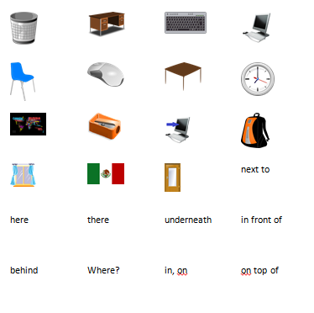
Example of game in progress:
AB
Page 4:

of the table= de la mesa
of the desk= del escritorio
of the backpack= de la mochila
of the mouse= del ratón
of the screen= de la pantalla
of the computer= de la computadora
of the keyboard= del teclado
of the door=de la puerta

1. The computer is on top of the desk. La computadora está encima del escritorio.

2. Your chair is behind the table. Tu silla está detrás de la mesa.

3. The mouse is next to the keyboard. El ratón está al lado del teclado.

4. My homework is underneath the notebook. Mi tarea está debajo del cuaderno.

Page 5

Escribe cierto o falso:
cierto 1. El reloj está al lado de la bandera.
falso 2. El teclado está debajo del escritorio.
Vocabulario importante:
al lado de= next to
debajo de= underneath
delante de= in front of
detrás de= behind
encima de= on top of
cierto 3. La computadora está encima del escritorio.
falso 4. La papelera está debajo de la puerta.
falso 5. La silla está detrás de la puerta.
cierto 6. El escritorio está debajo del reloj.
cierto 7. El escritorio está detrás de la papelera.
falso 8. La puerta está debajo de la papelera.
cierto 9. La silla está debajo de la bandera.
falso 10. La papelera está al lado del reloj.

Page 6
the flag= la bandera the flags= las banderas
a flag= una bandera some flags= unas banderas
the desk= el escritorio the desks= los escritorios
a desk= un escritorio some desks= unos escritorios

Remember, to make a noun plural that ends with a consonant, add “es.” If it ends with a z, change the z to a c and then add “es.”
the clock= el reloj the clocks= los relojes
a clock= un reloj some clocks= unos relojes
the pencil= el lápiz the pencils= los lápices
a pencil= un lápiz some pencils= unos lápices

Page 7: Solution

L A S M O C H I L A S D E L A M E S A
+ + + + + + + S E L E T R A C S O N U
E L S A C A P U N T A S + + + + + + +
S A N A T N E V S A L + + + + + + + +
U N A P A P E L E R A N Ó T A R U T +
+ + + + + L O S R E L O J E S + + + +
O T S E S E É U Q O D A L C E T L E D
U N A S C O M P U T A D O R A S + + +
S O I R O T I R C S E S O N U + + + +
M I C O M P U T A D O R A + + + + + +
S A R E D N A B S A N U + + + + + + +

(Over,Down,Direction)
DELAMESA(12,1,E)
DELTECLADO(19,7,W)
ELSACAPUNTAS(1,3,E)
LASMOCHILAS(1,1,E)
LASVENTANAS(11,4,W)
LOSRELOJES(6,6,E)
MICOMPUTADORA(1,10,E)
QUÉESESTO(9,7,W)
TURATÓN(18,5,W)
UNAPAPELERA(1,5,E)
UNASBANDERAS(12,11,W)
UNASCOMPUTADORAS(1,8,E)
UNOSCARTELES(19,2,W)
UNOSESCRITORIOS(15,9,W)

Page 8: Estar = to be
I am = yo estoy | we are= nosotros(as) estamos
you (informal) are= tú estás | you all are (when in Spain)=  vosotros(as) estáis
he is= él está  she is= ella está  you (formal) are= usted está | they (masculine) are= ellos están  they (feminine) are= ellas están  you all are= ustedes están

Note: When talking about an object, use the él/ella/usted form. When talking about multiple objects, use the ellos/ellas/ustedes form.

Modelo: La puerta está= the door is Las puertas están= the doors are

Frases:
I am here. Yo estoy aquí.
The chair is there. La silla está allí.
We are here. Nosotros estamos aquí.
The books are there. Los libros están allí.
You (informal) are in front of the door.
Tú estás delante de la puerta.
They (masculine) are next to the windows.
Ellos están al lado de las ventanas.
Page 9: Chapter Review
1. What is this? It’s a mouse!
¿Qué es esto? ¡Es un ratón!
2. There are eight computers here.
Hay ocho computadoras aquí.
3. I have some books in my backpack.
Tengo unos libros en mi mochila.
4. Where are you? (informal)
¿Dónde estás (tú)?
5. I am in front of the school.
Yo estoy delante de la escuela.
6. There are some chairs and some tables there.
Hay unas sillas y (unas) mesas allí.
7. Your pencil sharpener is under the keyboard.
Tú sacapuntas está debajo del teclado.
8. We are in front of Chipotle.
Nosotros estamos delante de Chipotle. (or delante del)
9. Ana and Paco are next to the window.
Ana y Paco están al lado de la ventana.

