ENG II H: MP2
ESSENTIAL QUESTION: TO WHAT EXTENT CAN INDIVIDUALS CONTROL THEIR OWN LIVES?

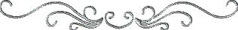
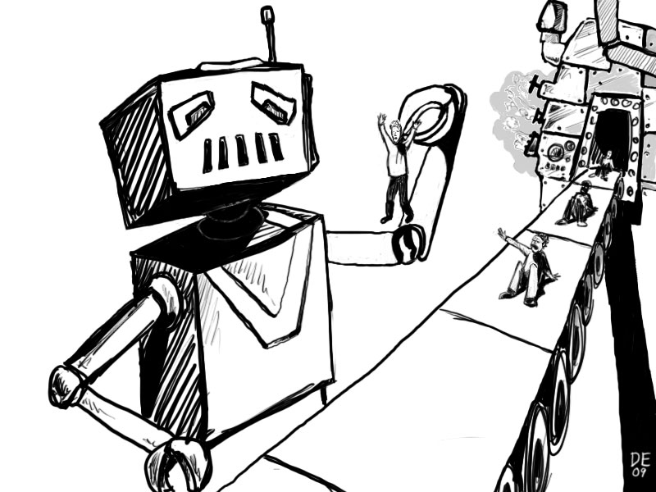
ESSENTIAL VOCAB
You need to familiarize yourselves with these terms, as well as your opinions regarding the different beliefs. Your Essential Vocab quiz will require you to not only recycle these definitions, but to APPLY them to various scenarios. Without forcing it, try to use these terms in class discussion in connection with our texts.

1. fate: Also known as destiny, fortune, luck, kismet (Turkish), happenstance, one’s “lot in life,” “in the stars,” Providence, beschert (Yiddish), “the way the cookie crumbles,” “what is written (in the stars),” etc., fate is something that ultimately and inevitably befalls a person, or something that is predetermined.

How fate is depicted in literature (you are responsible for this information!):
1. As you’ll see in Oedipus the King, men sought out oracles to learn their fates, but they could not alter their destinies in any way.

2. Many of Shakespeare’s tragedies involve their tragic heroes contemplating fate (i.e., Julius Caesar, Brutus, Romeo, Hamlet, Macbeth, etc.). “O, I AM FORTUNE’S FOOL,” Romeo shrieks in agony just after slaying Juliet’s cousin, Tybalt, realizing the catastrophic implications of what has just occurred; however, in saying this line, Romeo is condemning fate, not himself, for whatever retribution may follow. You may also remember Julius Caesar convincing his wife, Calpurnia, that he must go to the Capital on the Ides of March because “Brave men die but once ... it seems strange to me that men fear [it] ... death will come when it will come.”

2. free will: The belief that a person’s life is determined through free and independent choice and voluntary decisions. Example: “It’s not what happens to you, but how you react to it that matters,” or “Don't demand or expect that events happen as you would wish them do. Accept events as they actually happen. That way, peace is possible.” -Epictetus (both quotes - he often wrote/spoke about fate vs. free will).

3. predestination: The belief that all events are predetermined or preordained by a spiritual force (G-d). This idea was coined by philosopher John Calvin.

4. existential crisis: a moment in which an individual questions the meaning of his/her life, and whether or not it has any purpose, importance or meaning. It is often provoked by a significant life event - a marriage, separation, major loss, an important birthday or midlife crisis, the youngest child leaving for college, an illness, a near-death experience, etc. It’s often connected to the person beginning to cope with his/her own mortality and/or loss of youth.

5. karma: Based on Hindu and Buddhist beliefs, the simplest way to think of this belief is “What goes around comes around.” It is the belief that actions - good OR bad - will be rewarded or punished in either this life or the next.
http://www.youtube.com/watch?v=NIaiXmm1H0o&playnext=1&list=PLB03E8208555029B9&feature=results_video
6. fatalism: This philosophy is not what it sounds like (fatal). It is the acceptance of all things and events as inevitable - a submission to fate. For an example, look up the lyrics of an old song, “Que Sera Sera” (What Will Be Will Be) by Doris Day.
http://www.youtube.com/watch?v=MXQTWCTc0aI

7. The Butterfly Effect: Coined by Edward Lorenz, who claimed that a hurricane’s formation was contingent (dependent upon) whether or not a butterfly flapped its wings, The Butterfly Effect is the belief that even the tiniest, seemingly insignificant event can ultimately alter one’s life in significant ways in a sort of domino effect. (Did you ever play the board game “Mousetrap?” This presents a good visual example, too.) Additionally, The Butterfly Effect is a common trope in fiction, particularly when presenting scenarios involving time travel, or two or more divergent storylines. (There is also a 2004 movie by the same name, starring Ashton Kutcher, that we may be viewing later in the MP. For another example, rent or IMDB “Sliding Doors,” a 1998 Gwyneth Paltrow film.) The original “Jurassic Park” also references this theory; Ray Bradbury also based his 1952 short story, “A Sound of Thunder,” which we will be reading, around this theory. Last example: a 1993 short story called “The Mosquito’s Choice” by Henry Cowper holds a mosquito responsible for World War II having a very different outcome.
8. frame tale

