Confidential Information Sheet for Forensic Science 2012-13

Objectives:
I. You will be introduced to my teacher pages to obtain information about this class.
II. You will practice reading, following directions and handing projects in on time.
III. You will use your current technological skills to import a photo to an information sheet that
will be used by your teacher to help organize activities this year.

Directions:

1) Take a photo of yourself that shows your face and hairline similar to the photo you see in the example below.
DO NOT SMILE! Assume this is a photo taken by the police after you have been brought in and arrested. No one else but your teacher will see this photo so don’t worry about how ‘pretty’ or ‘handsome’ you are. If you want to see some celebrity mug shots for comparison go to http://www.youtube.com/watch?v=zChBJJbB6lo&feature=related

2) Download the photo from your camera and copy and paste your photo into the “Confidential Information” sheet just as Josh did in a previous year. Your final picture should be approximately 2.5 inches tall and 2 inches wide. You will have to resize your photo to make sure it fits in the appropriate space. Format your photo so the layout is ‘square.’ Your final document should look the same as the sample. If you move any of the boxes, you will need to reformat the document.

3) Fill in the information by deleting the information in red and typing your info into each box. You do NOT need to write in complete sentences. Make sure your information is on only one page! Do not hand in this direction page.

4) Save your page as a PDF file and e-mail it to me at mwalmsley@livingston.org Use the same e-mail address when you send it that is on your MO page.

NOTE: If you do not have a camera you can use for this assignment, you will need to make an appointment with me and use my camera. If you are having difficulty reformatting, I can help you. Use the request form below to make an appointment for help:

Cut on this line.

Request for use of camera and/or formatting help:

Name ________________________________

Date and time of appointment with Mrs. Walmsley: ____________________________________

Need help with:
_______ need camera to take photo
_______ need help with formatting photo for document
_______other ________________________________________________________
FS 12

Confidential information: “Modus Operandi”
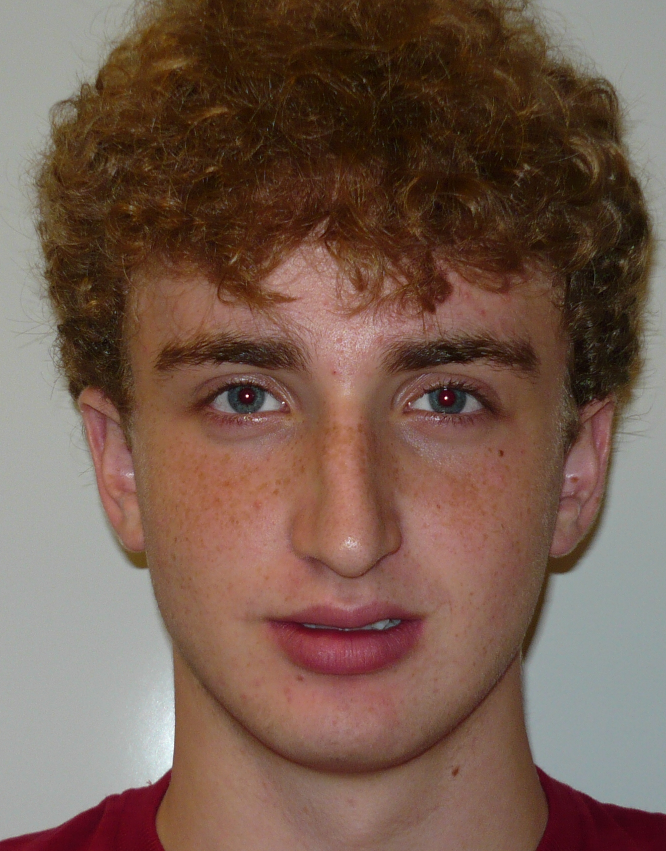
Please type Information in text boxes:

Last Name:
Dumbroff
Josh
Mad Hunter
098-098-0988
Madhunter@aol.com (use this e-mail when sending your info to mwalmsley@livingston.org)

First Name:
Nickname:
Cell Phone:

Your E-mail:

Prior and/or Current Science classes (include level):
Biology CP -09 Chemistry CP-10 Physics CP -11
Allergies/medical conditions that would limit your activities in this class (explain):
None known. Would like to sit near the front of the room to get a good view.

Please answer the following:
a
1) When in a group, I prefer to act as
a. leader b. follower C. a bit of both
a,b,f
2) I took this class because (choose all that apply)
a. I am interested in the subject
b. my guidance counselor recommended this class
c. I did not wish to take Physics but needed another lab science
d. I am interested in becoming a forensic scientist or other law associated worker
e. I need it to get enough credits to graduate
f. Other
I heard this class is an easy A if you work like a mad fool.

3) Describe your general responsibilities outside of this classroom so I know how busy your year will be. Include if you take AP classes, are in sports, have a job after school or plan on many extracurricular activities. Include if you plan to be out for March of the Living or an activity that will take you out of school for a long period of time (sports events).
I work at REI on weekends. I am a member of the baseball team in the spring. I plan to be out to the baseball training camp for one week during April. I am taking AP Statistics this year.
Finance
4) Currently, my main interest in college is to study

If any of the information above changes during the year, you will be responsible for sending a new, updated version of your MO.
The above information must be TYPED and it must fit on one page to be valid.

