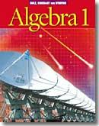 | Algebra 1 Honors  Final Exam  REVIEW  June 2014 | 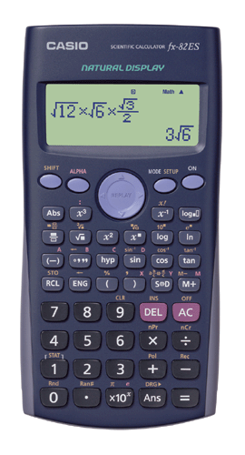

Name: Period:

Your final examination will consist of 40 multiple-choice questions worth one point each which will be completed on a Scantron form and 5 open ended questions worth a total of 14 points. The exam will include material from Chapters 6, 7, 8, 9, and 10 of your text.

NOTE: School policy mandates a penalty for cheating on an exam to be a grade of ZERO for that exam. The term cheating includes "intent to cheat." NO CELL PHONES. All cell phones must be kept out of sight. If a cell phone is seen during an exam, you will receive a grade of ZERO.

All calculators may be checked for inclusion of extraneous material. No papers should be placed in calculators. No information should be written on the front/back of calculators. The program portion of the graphing calculator will be checked. Any information entered there can be considered intent of cheating.

Before the examination, clear your calculator of any formulas, notes or any such items, which could be perceived as "useful" or providing unfair advantage. The best solution is to RESET and clear the memory completely.

The following pages provide a comprehensive review of the materials to be studied for this exam. We will take a few days of class time to review for this exam. Please feel free to stop in on your own time for further assistance. Good Luck!

Mr. Ladolcetta

Systems of Equations

TOPICS –
Types of systems – Consistent/independent, Consistent/dependent, Inconsistent.
Solving Word Problems – Coin, Number, Perimeter, and Age, Wind/Current, Etc.
Graphing – Inequalities, and Systems of Inequalities

PROBLEMS –

1. Match the graph to the type of system it represents:
I. II. III.

a. consistent/independent b. consistent/dependent c. inconsistent

2. Identify the system: 3x + 2y = 6
9x + 6y = 18

a. consistent/independent b. consistent/dependent c. inconsistent

3. Identify the system: 3x + 2y = 4
-3x – 2y = 4

a. consistent/independent b. consistent/dependent c. inconsistent

4. Copper that was 63% pure was mixed with copper that was 90% pure to make a mixture of 18 kg of
copper that was 75% pure. How much of each type of copper was used?

5. At full speed, an airplane can travel 4500 miles with the wind in 6 hours. It requires 10 hours against the
wind. What is the speed of the wind?

6. Cathy has $2.30 in dimes and quarters. If the number of dimes is 5 less than the number of quarters, how many coins of each type does she have?

7. A piggy bank has 225 dimes and quarters worth $27.45. Find how many dimes and how many quarters are in the bank.

8. Frank is four years older than Bill. Six years ago, he was twice as old as Bill. How old is Frank now?

9. At the afternoon matinee movie 3 adult tickets and 4 child tickets cost $41, and 4 adult tickets and 3 child tickets cost $43. How much is each adult ticket?

10. Graph the following: y < x + 3

11. Graph the following system:

- Graph the following system:

13. The length of a rectangle is 4 meters more than twice the width. The perimeter is 26 meters. Find the length and width.

14. A number is three less than four times another number. Their sum is one hundred two. What are the numbers?

Exponents

TOPICS –
LAWS OF EXPONENTS –
; ; ; ;

PROBLEMS –

- What is the value of when c = 3?

a. 3 b. 24 c. 27 d. 216

- In simplified form, is

a. b. c. d.

- In simplified form, is

a. b. c. d.

- In simplified form, =

a. b. c. d.

- In simplified form, is

a. w b. c. d.

- In scientific notation, 28,700,000,000 is written as:

a. b. c. d. 2.87

- In decimal notation, is

a. 0.000000000605 b. 0.00000000605 c. 0.00000605 d. 0.000000605

8. Find the value of: a. b. $\frac{{\text{10}}^{3}⋅{\text{10}}^{8}}{{\text{10}}^{5}}$ c.

9. Simplify: 10. Simplify:

11. Simplify: 12. Simplify:

13. Simplify: 14. Simplify:

15. Simplify:

16. Write each number in scientific notation:

a. 90,000,000 b. 0.00007 c. 305 d. 0.000406

17. Write each number in decimal notation:
a. b. 1.05 c. 3.2 d. 2.06

18. Simplify: $\left[\frac{−2r}{2r^{−5}}\right]\left[\frac{−{\text{rs}}^{−5}}{\left(−r^{4}s\right)}\right]$

19. Simplify $\left(4×{\text{10}}^{5}\right)\left(1\text{.}2×{\text{10}}^{8}\right)$. Give your answer in decimal notation.

20. Simplify $\frac{5\text{.}3⋅{\text{10}}^{−\text{23}}}{8⋅{\text{10}}^{−\text{23}}}$. Give your answer in scientific notation.

Polynomials and Factoring

TOPICS –
POLYNOMIALS –degree of, standard form, monomial, binomial, trinomial
Name by degree- constant, linear, quadratic, cubic, quartic
Adding, subtracting, multiplying, dividing
FACTORING – gcf, differences of squares, trinomials, factoring by grouping
Solving equations by factoring, simplifying rational expressions by factoring

PROBLEMS –

- The polynomial 3 -2x +1 is a

a. monomial b. binomial c. trinomial

- In standard form is

a. b. c.

- By degree, the polynomial 9 +1 is classified as

a. constant b. quadratic c. cubic d. quartic e. linear

- By degree, the polynomial -8x + 2 is classified as

a. constant b. quadratic c. cubic d. quartic e. linear

- Simplify:

a. b.
c. d.

- Simplify:

a. b.
c. d.

- Multiply / simplify:

a. b. c. d. 18

8. Multiply / simplify:

a. b. c. d.

9. Multiply / simplify:

a. b. 10x – x – 6 c. d.

10. Multiply / simplify:

a. b. c. d.

11. What is the GCF of and

a. b. c. d.

12. Factor:

- b.
c. d.

- What are the solutions to the equation ?

a. –2 and 3 b. 2 and –3 c. –2 and –3 d. 2 and 3

- Factor completely:

a. 9(x + 2)(x - 2) b. 3(x + 3)(3x + 4) c. 9(x – 4)(x + 1) d. 9

- Factor completely:

a. 16 b.
c. d.

- Factor completely:

a. b.
c. d.

- Simplify:

- Simplify and put in standard form:

- Simplify and put in standard form:

- Find each product:

a. b.

c. d.

e. f.

- Factor each completely:
a. b.

c. d.

e. f.

g. x⁴ – 81 h. 6x² – 19x – 20

i. x³ + 6x² – x – 6 j. 20x³ – 26x² + 8x

- Solve each equation by factoring:

a. b.

c. d.

e. 2x² + x = 11(2x + 1) f. 7b² – 14b = 0

23. Evaluate: for x = -3

- Find the missing value if:

- Simplify:

- Simplify:

27. Multiply: $\left(4y^{2}z+\text{12}y−4\right)\left(−3y^{2}z+8y−2\right)$

28. Fill in the following table:

POLYNOMIAL DEGREE NAME BY # OF NAME BY
DEGREE TERMS # OF TERMS

50x² – 3x + 2

12m + 8

-3.5

2y⁴ + y³ + 3y + 1

29. Simplify each expression by factoring. State any restrictions.

A. $\frac{5a+\text{10}}{5a}$ B. $\frac{3x−6}{x^{2}+x−6}$ C. $\frac{2x^{2}+\text{11}x+5}{x^{2}−\text{25}}$

Radicals

TOPICS –
Simplifying Square Roots
Adding, Subtracting Square Roots
Multiplying and Dividing Square Roots

PROBLEMS –

Simplify the following expressions.

1. $\sqrt{\text{300}}$ 2. 2$\sqrt{\text{162}}$

3. $3\sqrt{7}+8\sqrt{7}$ 4. $4\sqrt{2}−+4\sqrt{\text{192}}−\sqrt{\text{50}}$

15. $5\sqrt{\text{12}}−\text{10}\sqrt{\text{48}}$ 6. ${\left(8−\sqrt{3}\right)}^{2}$

7. $\sqrt{5}\left(−3\sqrt{8}−1\right)$ 8. $\frac{5}{\sqrt{7}}$

9. $\frac{\text{12}\sqrt{6}}{3\sqrt{\text{12}}}$

Quadratics

TOPICS –
Quadratic Equations – Solving by graphing, quadratic formula, discriminant,
Graphing Quadratic Equations
Word Problems

PROBLEMS –

1. Find the vertex and axis of symmetry of the graph of y = .5(x – 6)² – 3.

2. The vertex of the graph of y = x² + 8x – 9 is:

A. (4, 39) B. (-4, -57) C. (-4, -25) D. (4, 0)

3. The # of real solutions to the equation 3x² – 2x + 1 is:

A. 0 B. 1 C. 2 D. 3

4. The # of real solutions to the equation 4x = 4x² + 1 is:

A. 0 B. 1 C. 2 D. 3

5. The discriminant of 6x²+ 23x + 20 is:

A. 49 B. 7 C. -7 D. -49

6. Solve the following equations using the quadratic formula. Round to nearest tenth if needed

A. 2y² – 8y = 8 B. –x² – 3x - 10 = 0 D. x² – 15 x + 2 = 0

7. Graph the following functions clearly showing the vertex, axis of symmetry, and at least 4 other points.

A. f(x) = x² + 2 B. y = x² – 6x + 5

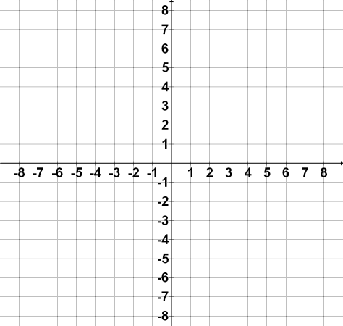

C. f(x) = -.5(x + 5)² + 7

8. To approximate the profit per day for her buisness, Mrs. Howe uses the formula p = -x² + 50x – 350. The profit, p, depends on the number of cases, x, of decorator napkins that are sold. How many cases of napkins must she sell to break even (not lose money)? To make the maximum profit? Find the maximum profit.

9. A boat fires an emergency flare that travels upward at an initial velocity of 25 meters per second. To find the height in meters, h, of the flare at t seconds, use the function h = -5t² + 25t. After how many seconds will the flare be at its maximum height? What is its maximum height? When will it hit the ground?

