CPES Name ________________________

Objective: Understand the plants, animals and climate that characterize each biome of the world.
Directions: Use the website (http://www.blueplanetbiomes.org/world_biomes.htm) to answer the following questions and color in the map below. Color the six major biomes on the world map.
Kinds of Ecosystems:
What is an ecosystem?
______________________________________________________________________________________________________________________________________
What is a biome? ___________________________________________________________________
___________________________________________________________________
___________________________________________________________________
Biomes of the World:
- Tundra 2) Taiga (Coniferous Forest) 3) Temperate forest
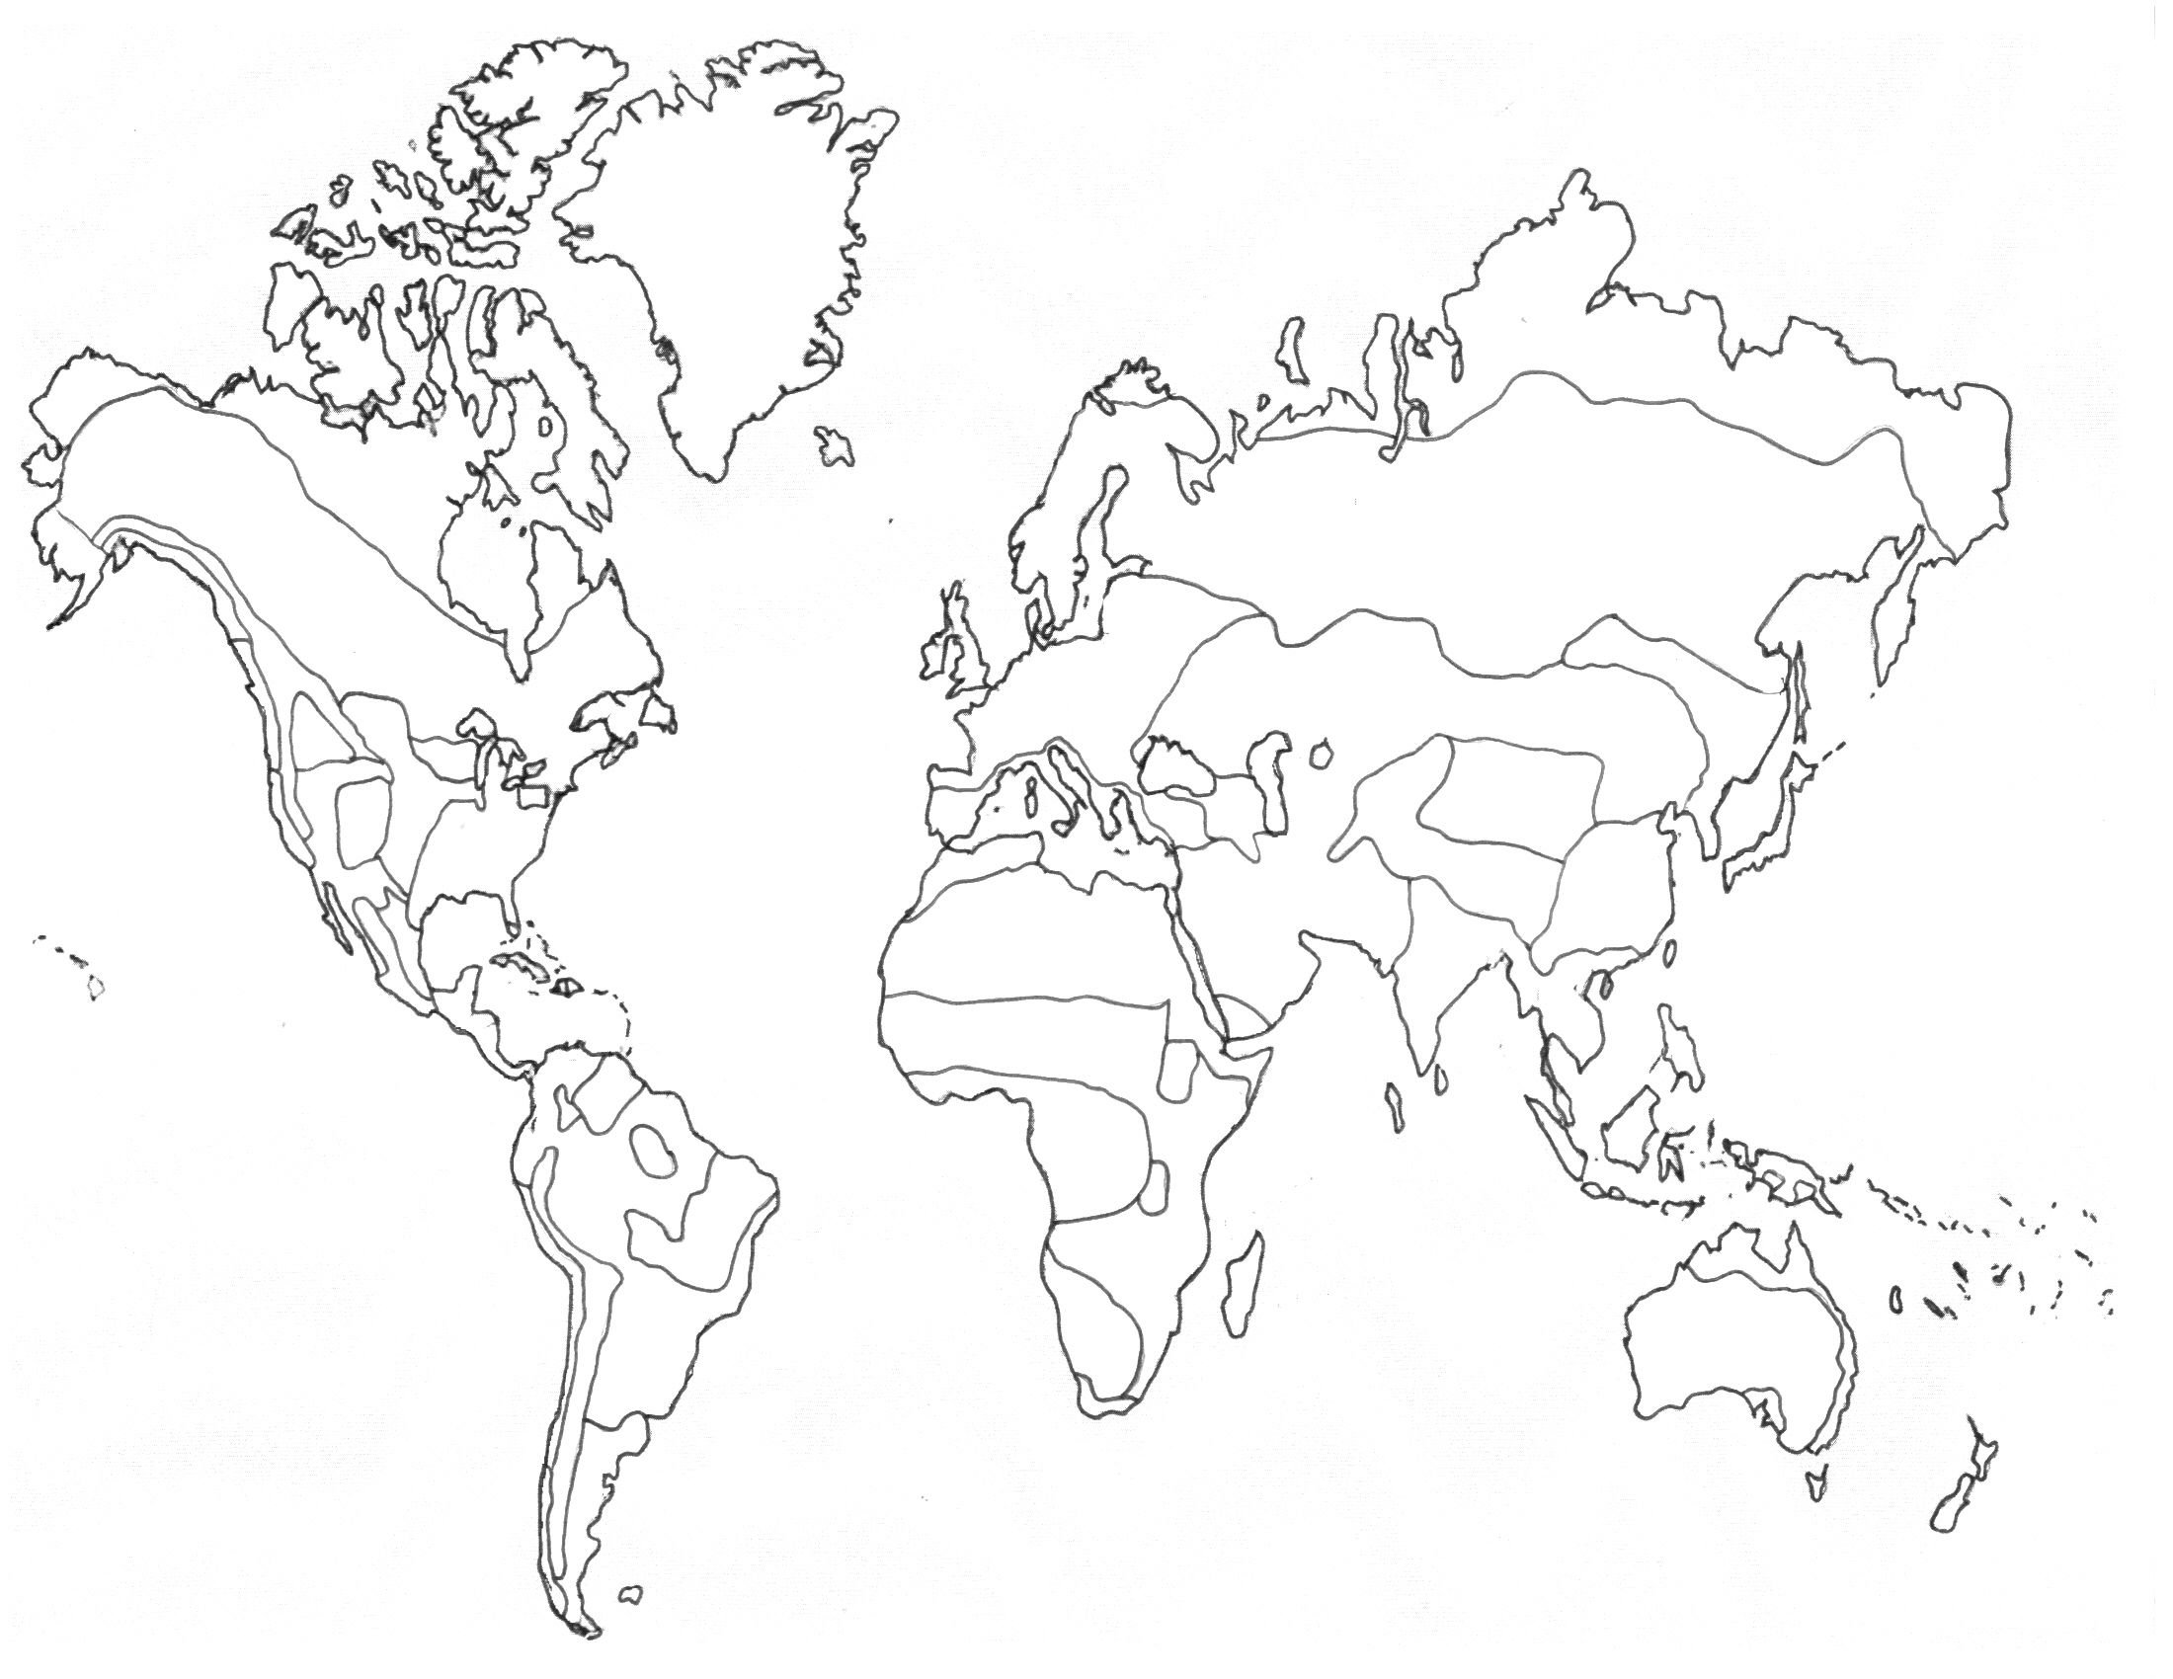
4) Tropical rainforest 5) Desert 6) Grassland/Savannah/Chapar
Directions: Use the website to Browse each biome and fill out the chart below. A few examples for plants/animals is fine.
Site: http://mbgnet.mobot.org/ - Missouri Botanical Gardens
Biome | Type of Plants | Types of Animals | Details & Climate (weather)
Rainforest
Tundra
Taiga
Desert
Temperate (deciduous forest)
Grasslands
*Browse the site to find the answers*

1. Describe the leaves of trees that live in the taiga.

2. How do trees in the taiga protect themselves from fire?

3. The changing of seasons is best viewed in which biome?

4. Second to the rainforest, which biome gets the most amount of rain?

5. What is the main difference between a hot and a cold desert (besides temperature)

6. Name the four major deserts of North America.

7. What is the world's largest desert?

8. In order to be classified as a "tropical rain forest" a forest must be located between what two Tropics?

9. Where can you find a rain forest in the United States?

10. What is the difference between an arctic tundra and an alpine tundra?

11. Relative to rainfall, the tundra is most like what other biome?

12. What are the three types of grasslands found in the United States?


Communities and Biomes

Across
2. Orderly, natural changes, and species replacements that take place in ecosystem communities over time.
3. Portion of the marine biome that is shallow enough for sunlight to penetrate.
4. Biome composed of large communities covered with grasses and similar small plants.
5. Coastal body of water, partially surrounded by land, in which freshwater and saltwater mix.
6. A stable mature community that undergoes little or no change in species over time.
8. Biome surrounding the north and south poles; treeless land with long summer days and short periods of winter sunlight.
9. Portion of the shoreline that lies between high tide and low tide lines.
10. Layer of permanently frozen found that lies underneath the topsoil of the tundra.
11. Portion of the marine biome that is too deep for sunlight to penetrate.
12. Any biotic or abiotic factor that restricts the existence, numbers, reproduction, or distribution of organisms.
13. Colonization of new land by pioneer organisms that is exposed by avalanches, volcanoes, or glaciers.
14. Group of ecosystems with the same climax communities.
15. Biome composed of forests of broad-leaved hardwood trees that lose their foliage annually.
16. Biome just south of the tundra; characterized by a northern coniferous pine, fir, hemlock, and spruce trees and acidic, mineral-poor topsoil.
Down
1. Arid region with sparse to almost nonexistent plant life; the driest biome.
2. Sequence of community changes that take place after a community is disrupted by natural disasters of human activities.
7. Biome near the equator with warm temperatures, wet weather, and lush plant growth.

