- Name 2 important steps for helmet fitting? _________________ ___________________

- Bicycling is dangerous. True or False?

- You only need to wear a bike helmet if you’re riding on the street. True or False?

- Bicycles are not toys, they are vehicles. True or False?

- Bicyclists don't have to get licenses, and they don't have to put license plates on their bikes.
True or False?

- So, they don't have to follow traffic rules like drivers and cars. True or False?

- It's OK to ride a bike that has some loose, broken or missing parts. True or False?

- It's OK for kids who are biking to ride on the sidewalk. True or False?

- If I am riding on the street, it's a good idea to drive my bike on the left side of the street, facing traffic, so I can see cars coming. True or False?

- Cyclists don't need to slow down and look for cars at intersections or driveways, because drivers will be able to see cyclists and stop in time. True or False?

- Navy blue is a good color to wear when riding your bike after dark. True or False?

- What do these signs mean?

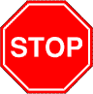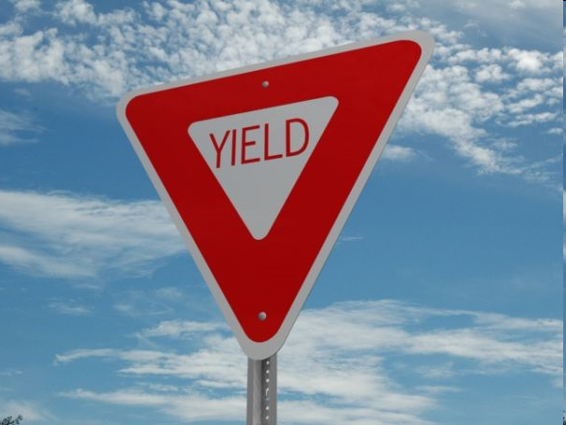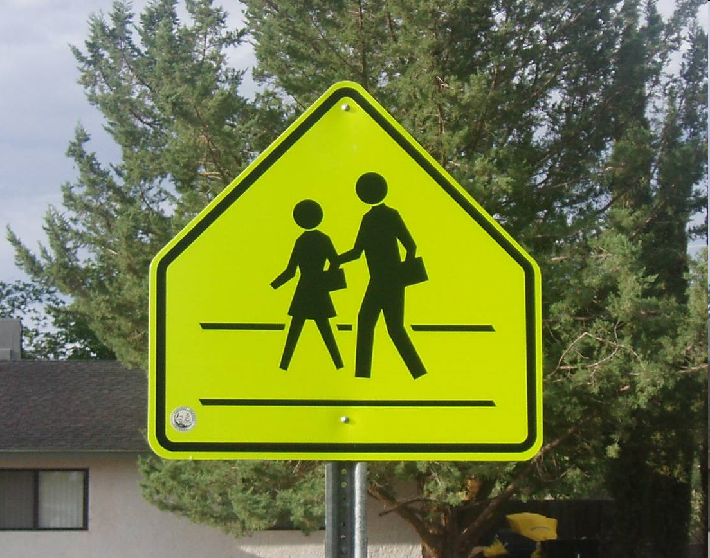

Cues | Questions | Yes / No
Two Finger Salute | Did you put two fingers above your eyebrows to make sure your helmet is flat on your head?
Two Fingers Under  Chin Strap | Did you strap your chinstrap and use two fingers to make sure it’s not too tight?
Yawn Test | Did you yawn and did your helmet pull down on your head?
Nod Yes and No | Did you nod yes and no to make sure your helmet doesn’t “Rock and Roll”?
V under ears | Do the straps form a V directly under your ears?

Try this activity at home with your parents.

How to fit a helmet.

Student Name:_____________________________________________________________

Parent Signature:____________________________________________________________

