Dear Harrison Artists,

It gives me great pride to send this note to you because I taught second grade at Harrison School a long time ago, and have always felt that good values and support of community were taught in the school. It appears that this is still the case.

The art work that you created for our Cycle for Survival event was such a colorful addition to a passionate, fun day.  We truly appreciate the time and planning this project required.

 New Jersey’s Cycle for Survival event was a HUGE success! We raised more than 1 million dollars to support laboratory research!!!  Many cancer patients attended the event; your artwork added to the happiness of the day.

Thank you very, very much for JOINING THE BATTLE!!

Join the Battle BEAT RARE CANCERS

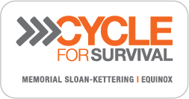

Sandy & Len Goodman

22 Berkeley Terrace

Livingston, NJ  07039

Phone: (973) 994 - 9440

[www.CycleforSurvival.org](http://www.CycleforSurvival.org)

DONATE TO TEAM:  A MISSION CONTINUED: JENNIFER GOODMAN LINN

