Customary Liquid Capacity

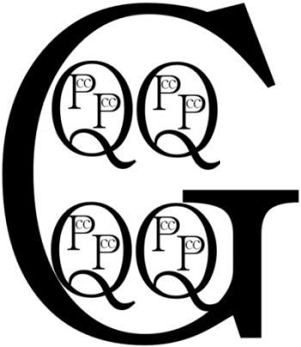

8 ounces = 1 cup