Customary Liquid Capacity Customary Liquid Capacity
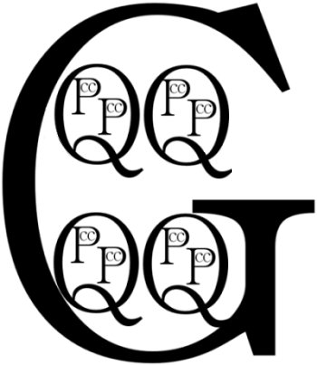
8 ounces = 1 cup 8 ounces = 1 cup

Customary Liquid Capacity Customary Liquid Capacity
8 ounces = 1 cup 8 ounces = 1 cup

Customary Liquid Capacity

8 ounces = 1 cup

