Polygons

Definition – a closed figure formed from line segments that has one interior space.
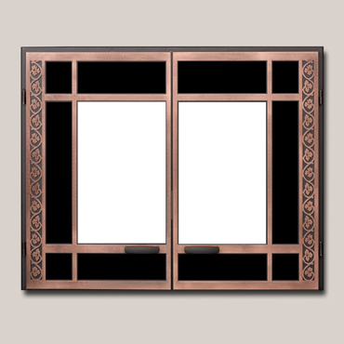

3 sided - Triangle 4 sided – Rectangle


5 sided - Pentagon 6 sided - Hexagon
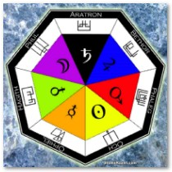
7 sided - Septagon 8 sided - Octagon



9 sided - Nanogon 10 sided - Decagon



11 sided - 11-gon 12 sided - Dodecagon

