Classifications of Triangles

Every triangle has two names ~ one that classifies its sides and the other that classifies its angles.

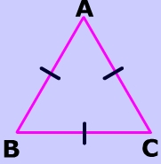
SIDES
An Equilateral triangle shown on the left has three
congruent sides and three equal angles.

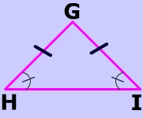

An Isosceles triangle has two equal sides
and two equal angles.

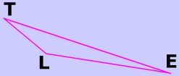
A Scalene triangle has no congruent sides.

ANGLES

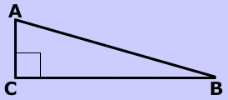
A Right triangle has one 90° angle.

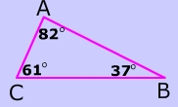
An Acute triangle has three acute
angles (an acute angle measures
less than 90° but more than 0°.)


An Obtuse triangle has an obtuse angle (an obtuse angle measures more than 90° but less than 180°). In the picture below, the shaded angle is the obtuse angle.

