**Geometry Notes – Arc Length and Areas of Sectors and Segments of Circles**

Arc length = C where m is the measure of the central angle and C is the circumference.

Area of sector =  where m is the measure of the central angle and r is the radius of the circle.

|  |
| --- |
| Example 1: Given: P and mAPC = 120˚ a. Find the length of  Arc length =  Arc length =  Arc length =  units |
| b. Find the area of the shaded sector.    4  Given: P and mAPC = 120˚  Asector =  Asector =  Asector =units2 |
| Example 2:  Note: Sector of Circle – Triangle = Segment of Circle  Given: P and mAPB = 60˚        **-**  **=**  -  =  units2 |

A farmer has a rectangular piece of property that is 150 feet by 200 feet. The farmer owns a sheep that he doesn’t want eating the grass on the whole piece of property. Therefore, he tied the sheep to a stake (using a 40 foot piece of rope) that is 25 feet from the fence on the east side of the property and 15 feet from the fence on the southern side of the property. How many square feet of grass can the sheep reach (round final answer to the nearest square foot).

150 feet

•

200 feet

Johnny doesn’t want his dog Spot digging holes all over the back yard so he tied the 30 foot leash to the corner fence post (point A in diagram). Unfortunately, Spot dug a hole under the fence 10 feet from point A on segment AB. How many square feet of ground are accessible to Spot (both inside the yard and out)?

**A**

**B**

**50 feet**

**100 feet**

Geometry Worksheet Name_____________________________________

Arc Length, Sector Area, Segment Area Date_____________________Period____________

Find the **shaded area**. On problems 1-3, find the arc length for the shaded sector also.

|  |  |  |  |
| --- | --- | --- | --- |
| 1. Asector = _____________  Arc length = __________    **120˚**    **90˚** | 2. Asector = _____________  Arc length = __________    **60˚** | | 3. Asector = _____________  Arc length = __________ |
| 4. Asegment = _____________      **60˚** | 5. Asegment = _____________    **120˚** | | 6. Asegment = _____________ |
| 7. If BC = 2AB, what fraction of the circle is shaded? (Hint: Let the AB = 2x. D is the center of the big circle. AB is the diameter of a little circle and BC is the diameter of a medium circle. Find the areas in terms of x.)    **A**  **B**  **C**  ●  **D** | | | |
| 8. Find the degree measure of the arc of a sector with area 36π if the area of the circle is 144π. | | | |
| 9. Two circles have radii 3 cm. and 5 cm. Find the ratio of their areas. | | 10. The areas of two circles are in the ratio 16 to 9. Find the ratio of their radii. | |

Answers:

1. Area = 36π u2 and arc length = 6π u 4.  7. 

2. Area = 147π u2 and arc length = 14π u 5. (25π – 50) u2 8. 90˚

3. Area = 8π/3 u2 and arc length = 4π/3 u 6. (48π - 36) u2 9.  10. 

**10-4 Perimeters and Areas of Similar Figures**

If the similarity ratio of two similar figures is , then

1. the ratio of their perimeters is  and
2. the ratio of their areas is .

4

5

Example 1: The triangles at the right are similar.

1. Find the ratio (larger to smaller) of the perimeters.
2. If the perimeter of the smaller triangle is 18 cm, find the perimeter of the larger triangle.
3. Find the ratio (larger to smaller) of the areas.
4. If the area of the larger triangle is 410 cm2, find the area of the smaller triangle.

Example 2: The ratio of the lengths of the corresponding sides of two regular octagons is . The area of the larger octagon is 320 ft2. Find the area of the smaller octagon.

Example 3: Benita plants the same crop in two rectangular fields, each with side lengths in a ratio of 2:3. Each dimension of the larger field is  times the dimension of the smaller field. Seeding the smaller field costs $8. How much money does seeding the larger field cost?

Example 4: The areas of two similar polygons are 32 in.2 and 72 in.2 If the perimeter of the smaller polygon is 15 in, find the perimeter of the larger polygon.

Notes – 10.8 – Geometric Probability

**Length Probability Postulate**:

If a point on  is chosen at random and C is between A and B, then the probability that the point is on  is:



0

1

2

3

4

5

6

7

8

9

D

E

F

G

H

I

Ex.

What is the probability a point chosen at random on  is also a part of:

(a)  (b) 

**Area Probability Postulate**

If a point in region A is chosen at random, then the probability that the point is in region B, which is in the interior of region A, is:



Ex. Joanna designed a new dart game. A dart in section A earns 10 points; a dart in section B earns 5 points; a dart in section C earns 2 points. Find the probability of earning each score.

**A**

**B**

**C**

radius of circle A = 2 in.

radius of circle B = 5 in.

radius of circle C = 10 in.

Ex. Find the probability that a point chosen at random in this circle will be in the given section.



**D**

**C**

**B**

**A**

**E**

50°

120°

60°

(a) A

(b) C

(c) D

Ex. Find the probability that a point chosen at random in each figure lies in the shaded region. Round your answer to the nearest hundredth.

8 cm

(a) (b)

Regular hexagon (sides = 12 cm) inside a rectangle

Shaded Areas

1. Dog Leash Problem - The garage at Juan’s house is outlined by polygon BCDEFG, and the adjacent yard is fenced along segments AB and AF. Juan tied his dog Ginger at point H which is 12 ft. from point B on segment GB. The leash on his dog is 15 ft. There is a small door for Ginger to go inside the garage at point G. Ginger has also dug a hole to get under the fence at point B.  
Shade and find the total area which Ginger can reach. Show your work to explain your reasoning.



2. A farmer has a rectangular piece of property that is 100 feet by 200 feet. The farmer owns a goat but he doesn’t want the goat getting into the vegetable garden so the goat is tethered (tied) to a stake in the ground using a 30 foot rope. The stake is 18 feet from the fence on the south side of the property and 15 feet from the east side of the property. How many square feet (round to the nearest square foot) of grass can the goat reach?

200 feet

100 feet

•

Find the area of the shaded portion in each figure. The “dots” are centers of circles.

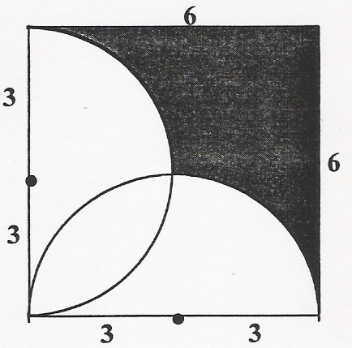

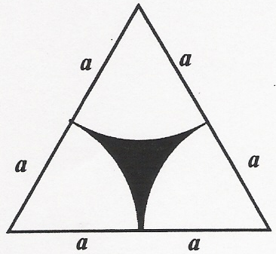

1. 4.

5. 6.

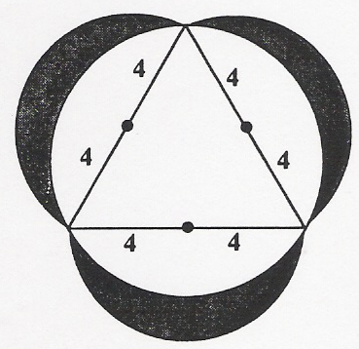

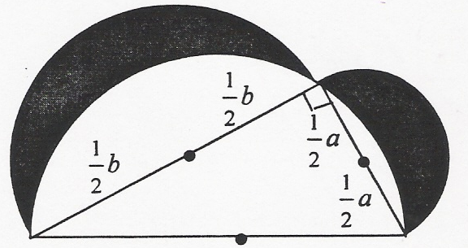

GT/Honors Geometry Name_______________________________

Chapter 10 Review – Area Date___________________Period________

For the following problems, find the area of the entire figure if nothing is shaded, or find the area of the shaded region if there is one. All answers should be exact unless you are asked to round.

|  |  |
| --- | --- |
| 1. A=_____________  15  10  45˚ | 2. A=___________ The area of a circle is 24π cm2. Find the circumference of this circle. |
| 3. A=________________  9  17  14 | 4. A=______________ Equilateral Triangle |
| 5. A=________________; p = ______________ Regular hexagon with semicircles attached  8 | 6. A=_________ ABCD is a rhombus with AC=18  A  B  C  D  E  41 |
| 7. A=__________ Find the area of a regular nonagon with sides of length 12 cm. Round to the nearest tenth. | 8. A=__________  Regular Polygon, round to the nearest tenth.  8 |
| 9. A=____________    24 | 10. Given: m∠ABC=100˚, CB = 15; A=__________; arc length = __________; probability of landing in the shaded area (exact) = __________  A  C  B |
| 11. A=_________ P = _______ probability of landing in the shaded area (nearest hundredth) = __________ __________  60˚  6 | 12. A=___________ ΔABC is equilateral. BD=DC=10. m∠DCB = 30˚.  A  C  D  B |
| 13. Find the area of an isosceles trapezoid that has bases 8 cm. and 18 cm. and that has legs that are 13 cm. long. | 14. Find the area of ΔMNP if m = 14, p = 16, and m∠MNP = 63°. Round your answer to the nearest tenth. |
| 15. Find the area of the triangle bounded by  x = -2, y = 4 and y = 3x – 2.  A=__________ | 16. Find the area of the quadrilateral ABCD with coordinates A(-1,5), B(6,4), C(2,-2), D(-5,2).  A=__________ |
| 17. AF=FG; FC=ED=FE=CD.  A=______________  P = _____________  A  B  C  D  E  F  G  9  15  semicircle | |
| 18. Joey has his dog on a leash tied to the corner of the garage. The garage is 20 feet by 30 feet. If the leash is 24 feet long, how much area can the dog access?  20  30  24 | |

Answers: (1) ; (2) ; (3) ; (4) ; (5) ; (24 + 12 )u; (6) 720 u2; (7) 890.2 cm2; (8) 110.1 u2 ; (9) ; (10) ; ; 5/18 (11) ;   
(6 + 2) u; .03; (12) ; (13) 156 cm2; (14) 99.8 cm2 ; (15) 24 u2; (16) 41.5 u2;   
(17) , (63 + 7.5) u; (18)  (Review quizzes)