Biology CP ’10-11 Name _________KEY_________________________

NOTE: Hang on to your Chemistry Notes Packet. You may use it for reference during this unit.
Unit 2: Ecological Biochemistry
PART B -Biochemical Structure

The study of the structure of organic chemicals found in living organisms.

2.3 Carbon Compounds
*What is the difference between ORGANIC and INORGANIC chemistry? organic chemistry means the study of compounds that contain bonds between carbon atoms; inorganic chemistry is the study of all other compounds
Why is Carbon so interesting?
- Carbon has *____4___ valence electrons, allowing it to form bonds with many other elements such as H, P, O, S and N.
- One carbon atom can bond to another, giving it the ability to form *___chains____ that are almost unlimited in length. These carbon-carbon bonds can be *__single_____, *__double_____ or even *_____triple_____ covalent bonds. Chains of carbon atoms can even close up on themselves to form *____rings________. No other element comes close to matching carbon's *____versatility______.

How many bonds does a single carbon atom form to become stable? ___4_____ (HONC 1234)
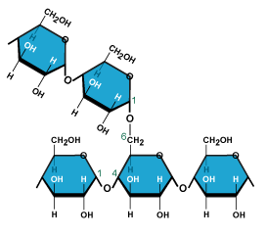
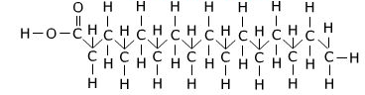

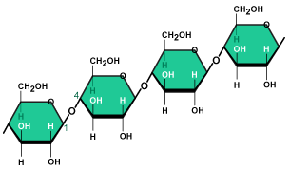

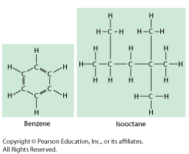

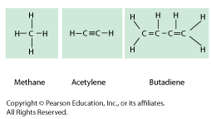

Two Major Types of Compounds:
___INORGANIC____ Compounds

- Usually defined as compounds that do not contain carbon with hydrogen. (exceptions may contain just carbon.)
- They often can be formed in the non-living (abiotic) environment, but :
- Can also be made by/found in living things.

examples: _______H₂O, NaCl, O₂, NH₃, CaCO₃ , CO₂__________________

___ORGANIC______ Compounds

- Usually defined as compounds which contain CARBON with HYDROGEN.
(May contain additional elements such as O, N, P, K, S, Fe, Ca, Na, Cl and others.)
- Produced only by living things (biotic).
- Range from simple to very complex.
- Contain strong, covalent bonds.

examples: _____CH₄, C₆H₁₂O₆, sugars, proteins, fats, oils, DNA __________

*Identify whether each of the following compounds is organic or inorganic by placing a √ in the appropriate column.

Substance | Organic? | Inorganic?
1. sodium chloride (table salt): NaCl |  | x
2. glucose: C₆H₁₂O₆ | x
3. water: H₂O |  | x
4. heating oil: C₁₄H₃0 | x
5. chitin (a protein): C₈H₁₂NO₅ | x
6. thymine (a nitrogenous base): C₅H₅N₂O₂ | x
7. sulfuric acid: H₂SO₄ |  | x
8. oxygen gas: O₂ |  | x
9. ethanol: C₂H₅OH | x
10. adenosine triphosphate (ATP): C₁₀H₁₆N₅O₁₃P₃ | x
11. carbon dioxide: CO₂ |  | x
The General Structure of Organic Compounds

Many of the organic compounds produced by living things are so large that they are called *____macromolecules_____ which means giant molecules.
Most macromolecules are fomed through a process called * polymerization in which * large compounds are built by * joining smaller ones together.
The smaller repeating units called *________________________ may be identical or different from one another. The large compounds which are formed from the joining of many monomers are called * polymers .
Two monomers joined together are called a __dimer________________.
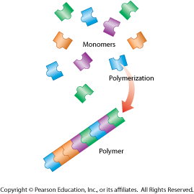

The exception: Lipids are not composed of monomers and polymers. Instead, they take different forms which we will discuss.
Simple organic compounds like glucose are produced by plants (producers) but consumers (like ourselves) must consume other organisms to obtain them. Then they must be digested and converted by metabolic processes into molecules we can use. All organisms must be able to use chemical process to BUILD and BREAK DOWN organic polymers.
Remember, there is a continual cycling of matter throughout all ecosystems.

Four Types of Biologically Important Organic Macromolecules:
The foods we eat are, of course, derived from living things and are therefore composed of a wide variety of different compounds. A well-balanced diet provides not only the energy needed to fuel life processes but also the materials needed for cells to build necessary compounds and cell structures.
 | Carbohydrates | Lipids | Nucleic Acids | Proteins
Foods in which they are found | Bread, cereals, pasta, fruit | Oils, butter, meat, dairy products, plant seeds | All types of foods derived from living things. | Meat, dairy products, beans
A major theme of Biology is “Form ads to Function”: The basic structure or ‘form’ of a molecule determines ‘function’ or do what it is designed to do.
NOTE: Your textbook goes into some detail of both the form and the function of organic molecules in this chapter. In this unit, however, we will be focusing primarily on the STRUCTURE (form) of these molecules. We will discuss their functions at various points throughout the year.
Carbohydrates
Carbohydrates are important for energy and cell structure.
- Sometimes called ‘hydrated’ carbons. They contain atoms of *__C______, __H______, and _O______, usually in a ratio of *_1_______ : ___2_____ : ___1_____.
- Carbohydrates differ in structural makeup. They range from small, monosaccharides (simple sugars) to intermediate molecules such as disaccharides, to large polysaccharides (complex carbohydrates).
*Monosaccharides: single sugar molecules. the simplest (monomer) unit of carbohydrates.
- Examples:
glucose  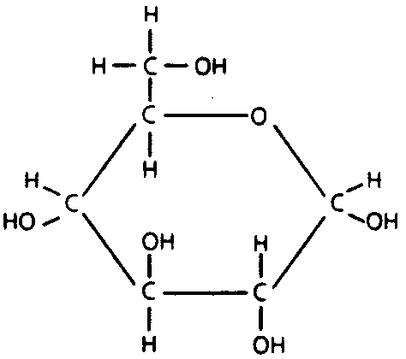 | galactose  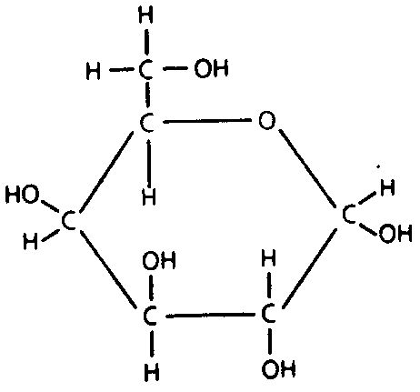 | fructose  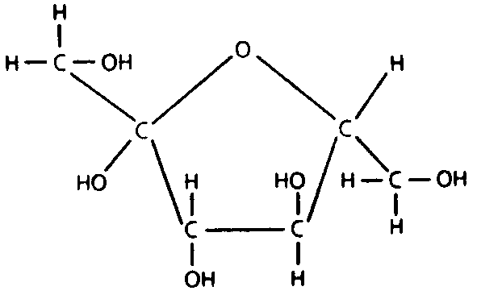 | ribose
Chemical Formula:  C₆H₁₂O₆ (All monosacch will be C_{n}H_{2n}O_{n}) | C₆H₁₂O₆ | C₆H₁₂O₆ | C₅H₁₀O₅
*Disaccharides: a compound made by joining two monosaccharides together

- Examples : sucrose - (table sugar) - made by joining *__glucose_______ and *__fructose____.
lactose - (milk sugar) - made by joining __glucose______ and ___galactose_____.
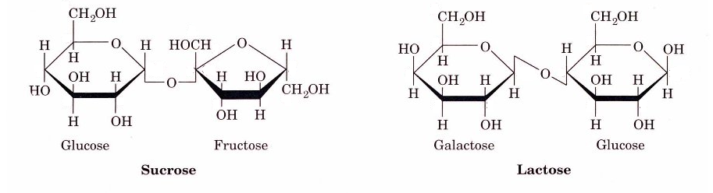

*Polysaccharides: large molecules formed from monosaccharides. aka complex carbohydrates
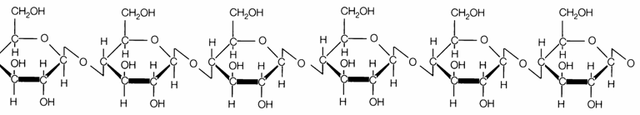
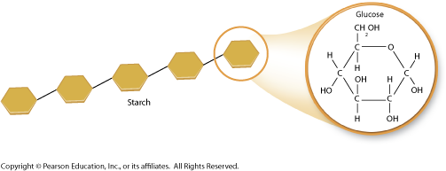
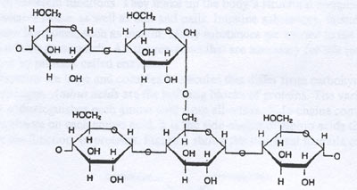

*What differences and/or similarities do you notice about the polysaccharides above?
They are all composed of ring-like structures of C,H,O (the simple sugars) but the bonds that connect them are drawn differently. Some are branched and some are formed in a diagonal manner. (Remember form leads to function.)

Important Polysaccharides Synthesized by Animals and Plants:

- ANIMALS—consume carbohydrates in food, digest them (hydrolysis) and then store the excess sugar by synthesizing:

*glycogen polysaccharide that many animals make to store excess sugar
Glycogen is an energy storage molecule made by animals, sometimes referred to as
"animal starch". When the level of glucose in your blood runs low, glycogen stored in the liver & muscles is broken down into *___glucose_____ which is released into the blood so it can be delivered to cells.

- PLANTS—produce glucose during photosynthesis and use it to synthesize:

*starch polysaccharide that plants make to store excess sugar
Starch a molecule made by plants to store excess sugar.

*cellulose polysaccharide that plants build to strengthen their cell walls
Cellulose is a molecule made by plants that forms the tough flexible fibers that give plants
much of their strength and rigidity.
Cellulose is a major component of the cell walls of plant cells.
Wood and paper are made largely of cellulose!
Humans generally can't digest cellulose ("fiber") - but it helps regulate the elimination of
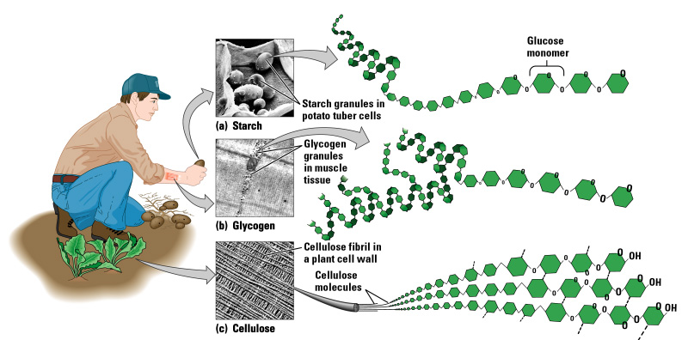
your solid wastes.

What do glycogen, starch and cellulose have in common?
1. all made of glucose monomers
2. all are polysaccharides
3. all contain only C, H, O

Lipids

Lipids are important for energy, cell structure, and waterproof coatings.

- Generally not soluble in *____water_____________.
- Contain mainly the elements *__C_______ and *___H____ but also contain small amounts of __O___.
- Lipids do not have a repeating structural monomer unit. They do not form polymers (unlike carbohydrates, proteins and nucleic acids which do).
- Types of lipids:
- fats______a triglyceride that is solid at room temperature_; usually from animal sources
examples ___butter, shortening, lard______________________________________________
2) oils____a triglyceride that is liquid at room temperature_; usually from plant sources
examples ___sunflower oil, olive oil, corn oil____________________________________
3) waxes - ear wax, beeswax, and the waxy layer on the surface of plant leaves.
4) steroids - cholesterol; hormones such as testosterone; pigments used in animal vision and in photosynthesis.
5) phospholipids – important structural component of cell membranes.

Steroids
Phospholipid

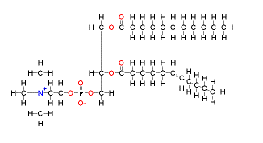
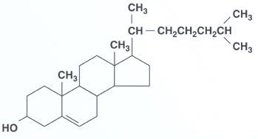
Cholesterol

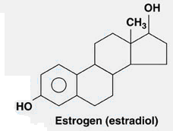

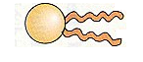
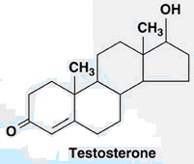

TRIGLYCERIDES are formed when a glycerol molecule combines with 3 molecules called fatty acids.
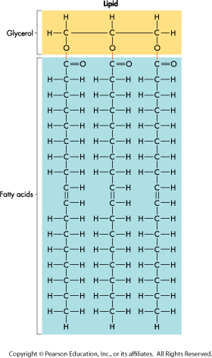
- Structure of Triglycerides (includes fats & oils):
- ___glycerol_____________________________________
- ___3 fatty acids________________________________
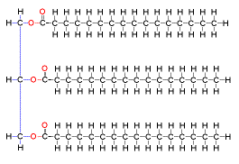
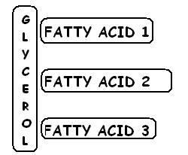

Saturated vs. Unsaturated

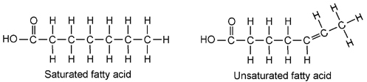

1) A fatty acid is said to be SATURATED if: * each carbon in a lipid's fatty acid chains is bonded to another carbon atom (no C=C double or triple bonds)

- tend to form molecules called saturated fats which are solid at room temperature.
- contain the maximum amount of hydrogens possible.
- unfortunately, not very 'heart-healthy'!

Note the Carboxyl group on the end of the fatty acid below. It is sometimes written as COOH or -COOH.
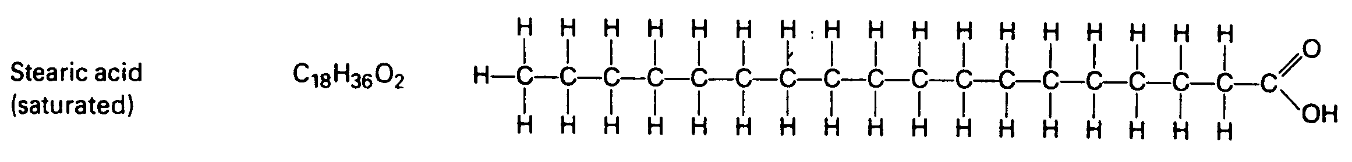

2) A fatty acid is said to be UNSATURATED if: *___there is at least one carbon-carbon double bond___

*polyunsaturated: lipids whose fatty acids contain more than one carbon-carbon double bond

- tend to form molecules called oils which are liquid at room temperature.
- contain fewer hydrogens
- these are more "heart-healthy"!
- food scientists can use a process called "hydrogenation" to artificially add hydrogens so that these molecules are more solid such as corn oil margarine, which makes them less healthy, unfortunately.

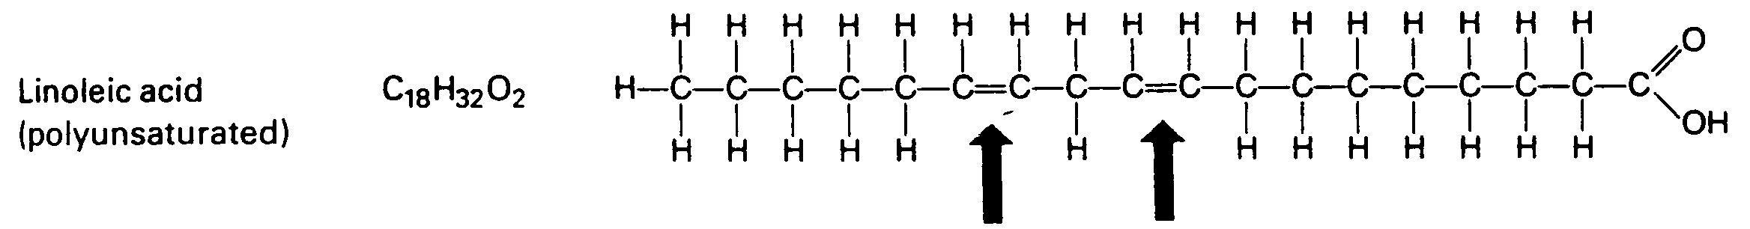

*Question: How might the structural forms of fatty acids affect whether they are solids or liquids at room temperature?
The ‘bend’ in the structure of the unsaturated fatty acid might make it difficult to lay next to other molecules to form a solid structure.
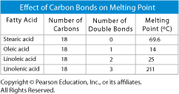

Nucleic acids store and transmit hereditary, or genetic, information;
Nucleic Acids
a special nucleotide called ATP stores & releases energy.

- Nucleic acids contain *__H____, ____O____, ____N___, _____C_____ and ______P______.
- Nucleic acid polymers are composed of repeating monomers, called:
*nucleotides __monomer units of nucleic acids. consist of 5-C sugar, phosphate group, nitrogenous base
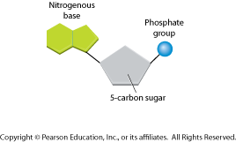
A special case: adenosine triphosphate (ATP)____a single nucleotide-not a nucleic acid polymer! Used as the cellular fuel in living things.
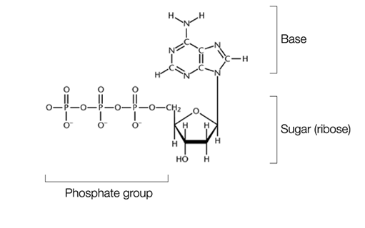

- Two important nucleic acid polymers found in all living cells:
- DNA - deoxyribonucleic acid - contains the sugar *____deoxyribose___________________.
Function: __holds the codes (genes) for cellular proteins Primary molecule of heredity.
- RNA - ribonucleic acid - contains the sugar *__ribose___________________.
Function: ___acts as DNA's "helper" in the creation of proteins in cells. Several types of RNA exist.
DNA and RNA have important structural & functional differences which we will discuss in more detail later this year.
Structures:
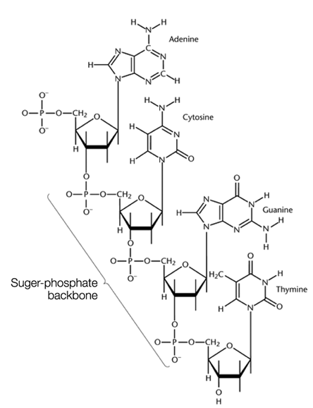
The DNA or genetic code of an organism determines what types of proteins are synthesized by its cell(s), which, in turn, determines its structural and functional traits.

There are many different types of proteins with a wide variety of functions. Some functions include: controlling the rate of
Proteins
reactions, regulating cell processes, formation of cellular structures, transporting substances into/out of cells, and
fighting disease.

- The most diverse group of organic compounds. Proteins are some of the largest and most complex compounds found in living organisms. Although 70% of your body is made of water, most of the other 30% is protein.
- Contain atoms of the elements *___N_____, __C______, ____H_____ and ____O______.
- Proteins are polymers of repeating monomers called * amino acids .
  - Small chains of amino acids are called ___polypeptides__________________________. Usually these are not yet fully functional - they must be built into finalized proteins.
  - *Protein: a functional molecule built from one or more polypeptides
- When they are first formed, proteins are linear (straight) chains of amino acids called polypeptides. Attractive forces (hydrogen bonds, ionic bonds, or covalent bonds) between the R groups cause the protein to fold up on itself forming a 3-dimensional structure that is unique to each type of protein. Sometimes multiple polypeptides join to form the final, functional protein.
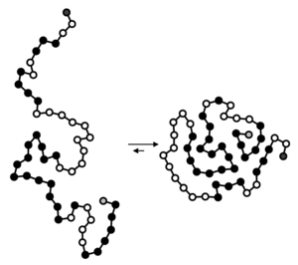
Remember, form leads to function!

Amino Acids

Amino acids are compounds with an *__amino__________ group (-NH2) on one end and a *_carboxyl____
(-COOH) group on the other end. More than *___20_________ different amino acids are found in nature.
Typical amino acid structure:  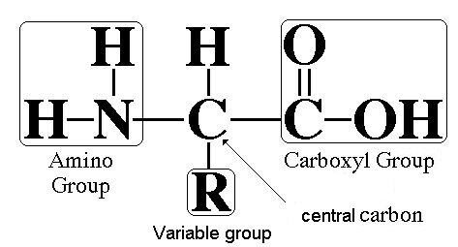 | Each amino acid consists of one of each of the following, connected to eachother by covalent bonds.  1) central carbon atom (-C-)  2) carboxyl group (-COOH)  3) amino group (-NH₂)  4) one hydrogen atom (-H)  5) 'R' (variable) group - one of 20 different side chains  Amino acids are identical except for their R group which may be acidic, basic, polar or nonpolar - thus differnt structures give different amino acids (and the resulting proteins) different properties.  FORM LEADS TO FUNCTION  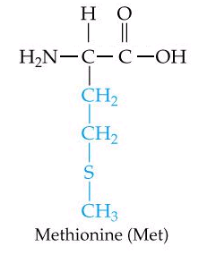  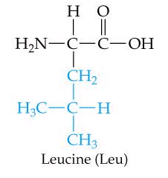  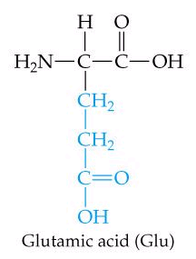  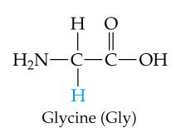
- Because of their uniform structure, any amino acid can bond to any other amino acid using a covalent bond called a peptide bond.

A peptide bond joins two amino acids by forming a bond between the *__-NH2_____ (amino) group of one
amino acid and the *__-COOH_________ (carboxyl) group of another. For each peptide bond formed,
one molecule of water is released due to the removal of -H and an -OH groups from the amino acids.
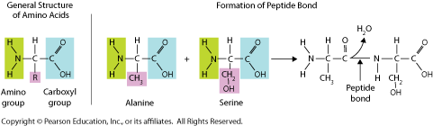
A short segment of amino acids (polypeptide):
How many amino acids are shown in the polypeptide above? *____6__________
How many peptide bonds are shown in the polypeptide above? *___5__________
How many water molecules were released as this polypeptide was formed?*_____5________
Proteins differ in the ___number_________ , __types___________ and ___sequence/order__ of their amino acids.

Formation or Breakdown of Organic compounds
(This section is not covered in your text.)
- Two major chemical processes (metabolic reactions) occur to build up or break down organic molecules into larger or smaller units.
  - Dehydration Synthesis Combining smaller organic subunits by the removal of water. involves removing an -H from one unit and an -OH from the other to allow the subunits to bond together.
-water is formed as a product

  - Hydrolysis Breaking apart larger organic molecules into their subunits by adding water. Involves adding back in an -H and an -OH so the molecules can exist separately.
-water is needed as a reactant

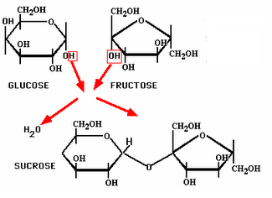
Disaccharide

Triglyceride
Nucleic Acid

Dipeptide

