CP Biology Name KEY Date Period

HOMEWORK PACKET

UNIT 2A

Part I: Introduction to Ecology
Name Class Date

3.1 What Is Ecology?
Studying Our Living Planet
- What is ecology?
The scientific study of interactions among organisms and between organisms and their physical environment.

- What does the biosphere contain?
All life on Earth and all parts of Earth where life exists

- How are human economics and ecology linked?
Humans live within the biosphere and depend on ecological processes to provide such essentials as food and water that can be bought and sold or traded.

Greek root word for eco = “houses”
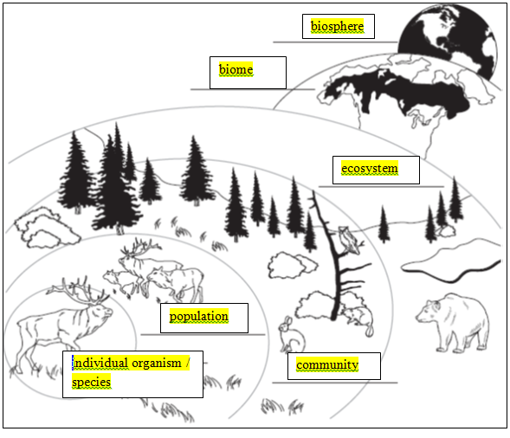
Use the diagram to answer Questions 4–5
1
- Label each level of organization on the diagram.
- Explain the relationship between ecosystems and biomes.
Biomes include different ecosystems that share similar abiotic (like climate and weather) and biotic (like plants and animals).

Biotic and Abiotic Factors
6. Use the terms in the box to fill in the Venn diagram. List parts of the environment that consist of biotic factors, abiotic factors, and some components that are a mixture of both.

air heat precipitation
animals mushrooms soil
bacteria plants sunlight

Both
Animals
Bacteria
Mushrooms
Plants

Biotic Abiotic
Factors Factors
Heat
Precipitation
Sunlight

Air
Soil

Ecological Methods
- Why might an ecologist set up an artificial environment in a laboratory?
Allows them to account for variables that they could not control in nature (i.e., climate, predators, etc.).

- Why are many ecological phenomena difficult to study?
They occur so slowly and over such a wide range (large expanse).

- Why do ecologists make models?
Allows them to study situations on a more manageable scale.

3.2 Energy, Producers, and Consumers
Primary Producers
1. What do autotrophs do during photosynthesis?
They convert sunlight (along with CO₂ and H₂O) into glucose (and release O₂)
2

2. Can some organisms survive without energy from the sun? Explain your answer.
Some organisms, called chemosynthesizers, can convert chemicals into energy (without the need for sunlight).

3. Can organisms create their own energy? Explain your answer.

No, they convert it to different forms (i.e., nutrients)

Consumers
4. Complete the table about types of heterotrophs.

Types of Heterotrophs
Type | Definition | Examples
Herbivore | Organism that eat plants or plant matter | cows, rabbits
Carnivore | Heterotroph that eats animals | Lions, snakes, dogs
Omnivore | Organism that eats both plants and animals | humans, bears, pigs
Detritivore | Organisms that feed on detritus (dead and decaying plant and animal remains) | Earthworms, snails, shrimp
Decomposer | Organisms that break down and obtain energy from dead organic matter | Bacteria and fungi
Scavenger | Heterotroph that consumes the carcasses of dead animals but does not typically kill them itself | Vulture, hyena

5. What is a consumer?
Heterotroph – obtains its energy by consuming other organisms
6. How would you categorize a consumer that usually catches and eats prey, but also eats dead animal carcasses? Carnivorous scavenger (opportunistic!)

3
3.3 Energy Flow in Ecosystems
Food Chains and Food Webs
1. Complete the table about feeding relationships.

Feeding Relationships
Relationship | Description
Food Chain | One way flow of energy; a simple series of steps in which organisms transfer energy by eating and being eaten
Food Web | A network of complex interactions formed by the feeding relationships among the organisms in an ecosystem

Use the food chain to answer Questions 2–4.
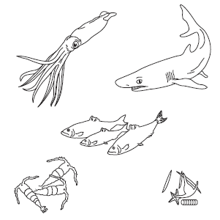
- Draw arrows between the organisms to show how energy moves through this food chain. Write producer, herbivore, or carnivore under each organism.
carnivore
herbivore
carnivore
carnivore
- Explain how energy flows through this food chain.
Producer
Energy flows from trophic level to trophic level, starting with the producers. ENERGY DOES NOT GET RECYCLED!

- What would happen to this food chain if a disturbance caused a serious decline in the shark population?
The squid population will increase, the fish population will decrease, the krill population will increase and the algae population will decrease.

- What role does energy play in the diagram, and how is it represented?
VISUAL ANALOGY
Energy flows in a one-way direction and Matter is recycled

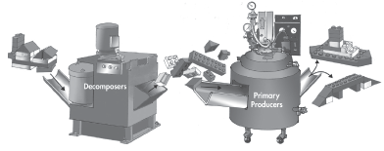

Trophic Levels and Ecological Pyramids
Write True or False on the line provided.
F 6. Primary consumers (producers) always make up the first trophic level in a food web.
T 7. Ecological pyramids show the relative amount of energy or matter contained within each trophic level in a given food web.
F 8. On average, about 50 (10) percent of the energy available within one trophic level is transferred to the next trophic level.
F 9. The more levels that exist between a producer and a given consumer, the larger (smaller) the percentage of the original energy from producers is available to that consumer.

5
Use the diagram to answer Questions 10–17. Match the organism with its trophic level. A trophic level may be used more than once.
Organism
1 10. algae
2 11. grasshopper
1 12. marsh grass
4 13. marsh hawk
3 14. plankton-eating fish
2 15. ribbed mussel
3 16. shrew
2 17. zooplankton

6

Match the term with its definition.

Term
D 1. nutrient
B 2. chemosynthesis
C 3. consumer
A 4. ecosystem
H 5. photosynthesis
F 6. ecology
E 7. primary producer
G 8. biosphere
Definition
- all the organisms in one area and their physical environment
- a process in which producers use chemical energy to make carbohydrates
- an organism that feeds on other organisms
- a chemical substance that an organism needs to survive
- an organism that uses chemical or light energy to produce its own food supply
- the study of the biosphere
- the portion of Earth and its atmosphere that contains organisms
- a process in which producers use light energy to make carbohydrates
7

For Questions 9–12, complete the analogies.
  - omnivore : human :: carnivore : lion
  - detritivore : earthworm :: herbivore : cow
  - autotroph : heterotroph :: phytoplankton : zooplankton
  - biotic factor : elephant :: abiotic factor : sunlight
  - What is the difference between a food chain and a food web?
Food web is a more complicated collection of inter-related food chains

Complete each statement by writing the correct word or words.
  - There are several hundred squirrels living in an oak forest. The squirrels make up a(n) population .
15. Fungi and some kinds of bacteria are decomposers that obtain nutrients by chemically breaking down organic matter.
16. Ecologists measure detritus in grams of organic matter per unit area.
17. In a process known as , some types of soil bacteria obtain energy by converting nitrates into nitrogen gas.

4.2 Niches and Community Interactions

The Niche
1. What is a niche?
The habitat and role of an organism in nature.

2. Give an example of resources a squirrel might need.
Shelter, food, water, etc.

3. Three different warbler species live in the same tree. One species feeds at the top of the tree, the second species feeds in the middle part of the tree, and the third species feeds at the bottom of the tree. Do all three species occupy the same niche? Explain.
No, they are not directly competing for the same space or food source. This is a better scenario than competing against eachother (uses less energy).

8

Competition
For Questions 4–8, write True if the statement is true. If the statement is false, change the underlined word or words to make the statement true.
True 4. Competition occurs when organisms attempt to use the same resources.
False 5. Competition between members of the same species is known as interspecific intraspecific competition.
6. The competitive exclusion principle states that no two organisms can occupy exactly the same niche in exactly the same habitat at exactly the same time.
True 7. If two species of bacteria are grown in the same culture, one species will always outcompete the other.
8. Members of the same species tend to divide resources instead of competing over them.
Predation, Herbivory, and Keystone Species
Write the letter of the correct answer on the line at the left.
9. A lion eating a zebra is an example of
A. herbivory. C. predation.
B. habitat destruction. D. a keystone species.
10. A cow eating grass is an example of
A. herbivory. C. habitat destruction.
B. predation. D. a keystone species.
11. A keystone species is one that
A. eats a mixture of plants and animals.
B. is introduced into a community after a major disturbance.
C. causes the amount of diversity in a community to decrease.
D. helps to stabilize the populations of other species in the community.

4.4 Biomes

The Major Biomes
For Questions 1–4, complete each statement by writing the correct word or words.
1. The side of a mountain range that faces the wind often receives more precipitation than the downwind side of the same range.
2. A(n) biome is a group of terrestrial communities that covers a large area and is characterized by certain soil and climate conditions and particular types of plants and animals.
3. Organisms within each biome can be characterized by tolerance that enable them to live and reproduce successfully in the environment.
4. In a tropical rain forest, the layer formed by the leafy tops of tall trees is called the canopy and the layer of shorter trees and vines is called the understory .
9

