College/Alg Trig 2.2 Even and Odd Functions Name: _______________________

We can classify the graphs of functions as either even, odd, or neither.

Even | Odd
A function is an even function if _____________  for all x in the domain of f.  *The right side of the equation of an even function does NOT change if x is replaced with –x.  Even functions are symmetric with respect to the ____________________. This means we could fold the graph on the axis, and it would line up perfectly on both sides! | A function is an odd function if ______________  for all x in the domain of f.  *Every term on the right side of the equation changes signs if x is replaced with –x.  Odd functions are symmetric with respect to the ____________________. This means we can flip the image upside down and it will appear exactly the same!

If we cannot classify a function as even or odd, then we call it neither!

Directions: Determine graphically using possible symmetry, whether the following functions are even, odd, or neither.

1.  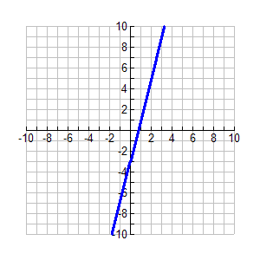 | 2.  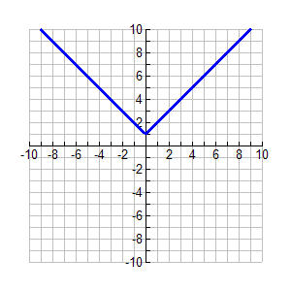 | 3.  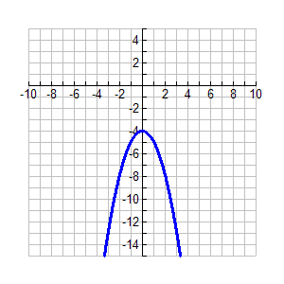
4.  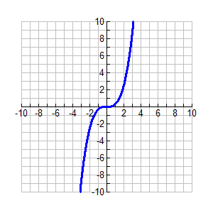 | 5.  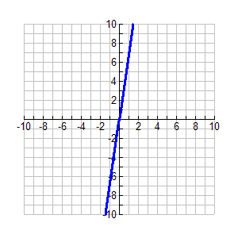 | 6.  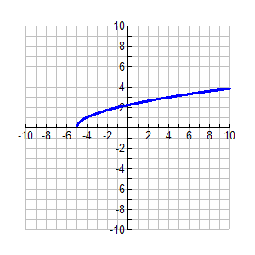

To verify algebraically if a function is even, odd, or neither, we must prove one of the following.

For even prove: _____________________ For odd prove: ____________________

If neither of the above are true, we call the function neither!

Function Notation | What to do | Example.
$$f(x)$$ | Repeat the original function. | $$f\left(x\right)=x^{2}+3x+5$$
$$f(-x)$$ | Plug in a ________ for every x and simplify! | $$f\left(x\right)=x^{2}+3x+5$$
$$-f(x)$$ | Change every sign you see in $f(x)$. If something starts positive, it changes to negative and if it starts negative, it changes to a positive. | $$f\left(x\right)=x^{2}+3x+5$$

Directions: Verify algebraically whether each function is even, odd, or neither!

1. $f\left(x\right)=x^{3}-6x$

2. $g\left(x\right)=x^{4}-2x^{2}$

3.${h\left(x\right)=x}^{2}+2x+1$

4. $f\left(x\right)=x^{2}+6$

5. $g\left(x\right)=7x^{3}-x$

6. $h\left(x\right)=x^{5}+1$

7. $f\left(x\right)=x\sqrt{4-x^{2}}$

8. $g\left(x\right)=x^{4}\sqrt{1+x}$

9. $h\left(x\right)=\left|x\right|-1$

10. $g\left(x\right)=\frac{1}{4}x^{6}-5x^{2}$

