Geometry  **Proof Practice Worksheet**  Name: ____________________________

1. **Given:**  = 9

**Prove:** *x* = 3

|  |  |
| --- | --- |
| **Statements** | **Reasons** |
|  |  |

2. **Given:**

**Prove:**

|  |  |
| --- | --- |
| **Statements** | **Reasons** |
|  |  |

3. **Given:**

**Prove:**

|  |  |
| --- | --- |
| **Statements** | **Reasons** |
|  |  |

4. **Given:**

**Prove: $x=2$**

|  |  |
| --- | --- |
| **Statements** | **Reasons** |
|  |  |

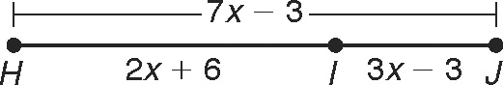4. Write a reason for each step.

HJ  HI  IJ

7x  3  (2x  6)  (3x  3)

7x  3  5x  3

7x  5x  6

2x  6

x  3

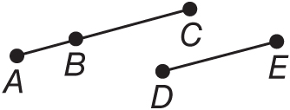

5. **Given:** *BC* = *DE*

**Prove:** *AB* + *DE* = *AC*

|  |  |
| --- | --- |
| **Statements** | **Reasons** |
| **1.** *BC* = *DE* | **1.** |
| **2.** | **2.** Segment Addition Postulate |
| **3.** *AB* + *DE* = *AC* | **3.** |

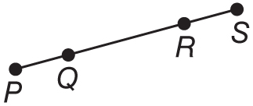

6. **Given:** *Q* is between *P* and *R*,

*R* is between *Q* and *S*, *PR* = *QS*.

**Prove:** *PQ* = *RS*

|  |  |
| --- | --- |
| **Statements** | **Reasons** |
| **1.** *Q* is between *P* and *R*.  *R* is between *Q* and *S* | **1.** |
| **2.** *PQ* + *QR* = *PR*  _______________ | **2.** Segment Addition Postulate |
| **3.** _______________ | **3.** Given |
| **4.** *PQ* + *QR* = *QR* + *RS* | **4.** |
| **5.** *QR* = *QR* | **5.** |
| **6.** *PQ* = *RS* | **6.** |

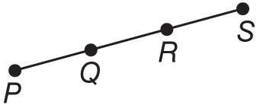7. **Given: $\overline{AB}$**  ≅ $\overline{DE}$

*B* is the midpoint of $\overline{AC}$.

*E* is the midpoint of $\overline{DF}$.

**Prove: $\overline{BC}$**  ≅ $\overline{EF}$

|  |  |
| --- | --- |
| **Statements** | **Reasons** |
| **a. ________________________________________**  **_________________________________________**  **_________________________________________** | **a.** Given |
| **b. ________________________________________**  **_________________________________________** | **b.** Definition of Midpoint |
| **c.** *AB* = *DE, AB = BC, DE = EF* | **c. _________________________________________** |
| **d.** *BC* = *DE* | **d. _________________________________________** |
| **e.** *BC* = *EF* | **e. _________________________________________** |
| **f. _________________________________________** | **f. _________________________________________** |

8. Given: N is the midpoint of , Q is the midpoint of , and .

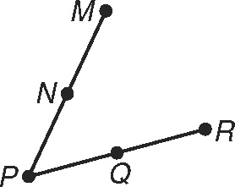 Prove: 

Write a justification for each step.

Proof:

1. N is the midpoint of . 1.

2. Q is the midpoint of . 2.

3.  3.

4.  4.

5.  5.

6.  6.

7.  7.

9. Complete the following proof:

3

2

4

1

**Given**:

**Prove**: 

**Proof:**

|  |  |
| --- | --- |
| **Statements** | **Reasons** |
| **1.**  **2. $∠1 and ∠2 are vertical angles.$**  **3. $∠3 and ∠4 are vertical angles$**  **4.** ;  **5.** | **1.**  **2.**  **3.**  **4.**  **5.** |

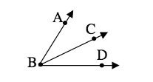

10. Given:

Prove: $\vec{BC}$ bisects $∠ABD$

|  |  |
| --- | --- |
| **Statements** | **Reasons** |
| **1.**  **2. $m∡ABC=m∡CBD$**  **3. $\vec{BC}$**  is an angle bisector  **4.** | **1.**  **2.**  **3.**  **4.** |