Name: \_\_\_\_\_\_\_\_\_\_\_\_\_\_\_\_\_\_\_\_\_\_\_\_\_\_\_\_\_\_\_\_\_\_\_\_\_\_\_\_\_\_\_\_ Period: \_\_\_\_\_\_\_\_\_\_\_ Date: \_\_\_\_\_\_\_\_\_\_\_\_\_\_\_

**Scatterplots – Practice 9.1A**

Describe the correlation you would expect between the data. Explain.

1. The age of an automobile and its odometer reading.
2. The amount of time spent fishing and the amount of bait in the bucket.
3. The number of passengers in a car and the number of traffic lights on the route.
4. 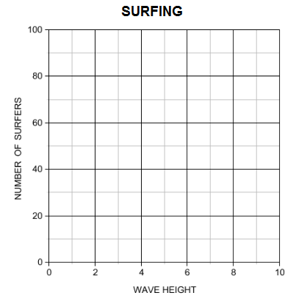The table shows the heights (in feet) of the waves at a beach and the numbers of surfers at the beach.

|  |  |  |  |  |  |
| --- | --- | --- | --- | --- | --- |
| Wave Height | 3 | 6 | 5 | 1 | 4 |
| Number of Surfers | 24 | 61 | 56 | 15 | 35 |

* 1. Plot the data from the table on the graph.
  2. Describe the relationship between the two data sets.
  3. How many surfers might be at the beach if the waves

were 2 feet high?

1. The scatter plot shows the numbers of lawns mowed by a local lawn care business during one week.

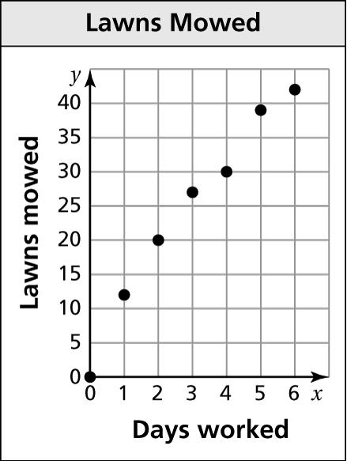

* 1. How many days does it take to mow 30 lawns?
  2. About how many lawns can be mowed in 1 day?
  3. Describe the relationship shown by the data.

1. Describe the relationship between the data. Identify any outliers, gaps, or clusters.

|  |  |
| --- | --- |
| * 1. TA: C:\replacearts\Blue Resources by Chapter\Blue Chapter 9 RBC\Arts\PNGs\mscc8_rbc_0901_01.png | * 1. TA: C:\replacearts\Blue Resources by Chapter\Blue Chapter 9 RBC\Arts\PNGs\mscc8_rbc_0901_02.png |

1. 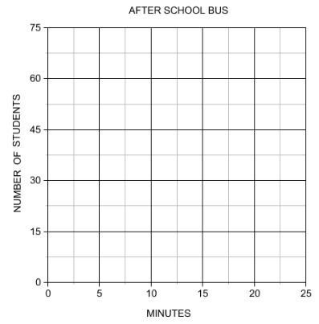The table shows the numbers of students remaining on an after-school bus and the numbers of minutes since leaving the school.

|  |  |  |  |  |  |  |  |
| --- | --- | --- | --- | --- | --- | --- | --- |
| Minutes | 0 | 5 | 9 | 15 | 23 | 26 | 32 |
| Number of students | 56 | 45 | 39 | 24 | 17 | 6 | 0 |

* 1. Plot the data from the table on the graph.
  2. Describe the relationship between the two data sets.

1. 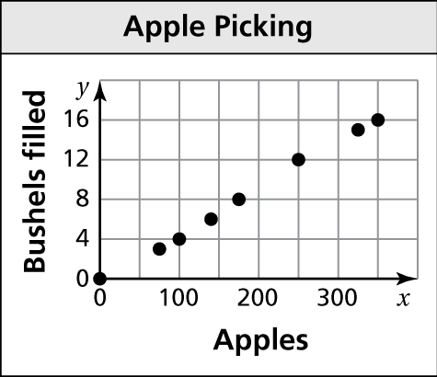The scatter plot shows the numbers of bushels filled and the numbers of apples picked.
   1. How many bushels are needed for 350 apples?
   2. About how many apples can be placed in 8 bushels?
   3. Describe the relationship shown by the data.

Name: \_\_\_\_\_\_\_\_\_\_\_\_\_\_\_\_\_\_\_\_\_\_\_\_\_\_\_\_\_\_\_\_\_\_\_\_\_\_\_\_\_\_\_\_ Period: \_\_\_\_\_\_\_\_\_\_\_ Date: \_\_\_\_\_\_\_\_\_\_\_\_\_\_\_

**Scatterplots & Line of Best Fit – Practice 9.2A**

1. 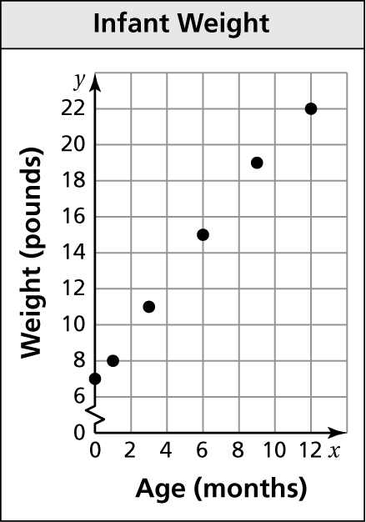The scatter plot shows the weights *y* of an infant from birth through *x* months.
   1. At what age did the infant weigh 11 pounds?
   2. What was the infant’s weight at birth?
   3. Draw a line that you think best approximates the points.
   4. Write an equation for your line.
   5. Use the equation to predict the weight of the infant at 18 months.
   6. Does the data show a *positive*, a *negative*, or *no* relationship?
2. The table shows the numbers of losses *y* a gamer has *x* weeks after getting a new video game.

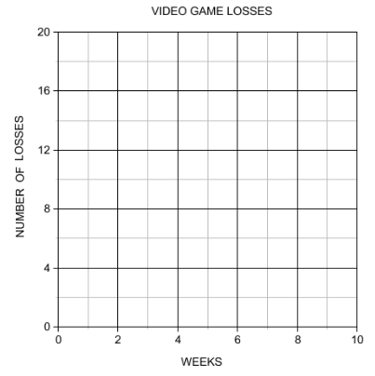

|  |  |  |  |  |  |  |  |
| --- | --- | --- | --- | --- | --- | --- | --- |
| Week, *x* | 1 | 2 | 3 | 4 | 5 | 6 | 7 |
| Losses, *y* | 15 | 12 | 10 | 7 | 6 | 3 | 1 |

* 1. Make a scatter plot of the data.
  2. Draw a line of fit.
  3. Write an equation of the line of fit.
  4. Does the data show a *positive*, a *negative*,

or *no* relationship?

* 1. Interpret the relationship.

1. 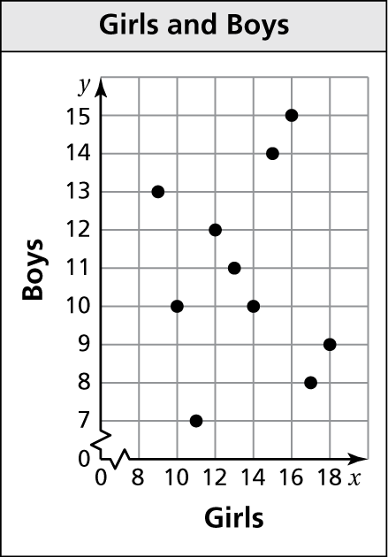The scatter plot shows the relationship between the numbers of girls and

the numbers of boys in 10 different classrooms.

* 1. What type of relationship, if any, does the data show?
  2. Is it possible to find the line of fit for the data? Explain.
  3. Is it reasonable to use this scatter plot to predict the number

of boys in the classroom based on the number of girls? Explain.

1. The scatter plot shows the costs *y* of bottles containing *x* fluid ounces of juice.
   1. How much does a gallon of juice cost?

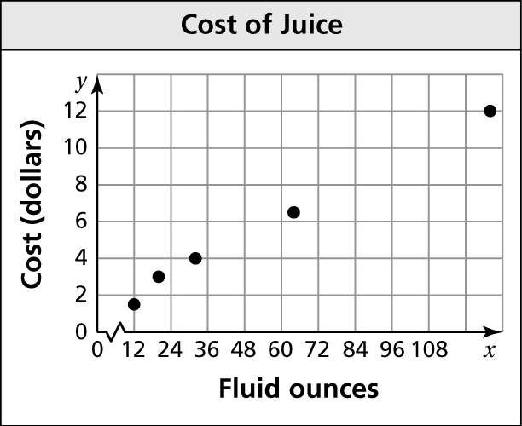

* 1. How many fluid ounces of juice can you purchase for $3?
  2. Draw a line that you think best approximates the points.
  3. Write an equation for your line.
  4. Use the equation to predict the cost of a 256-fluid

ounce container of juice.

* 1. Does the data show a *positive*, a *negative*, or *no* relationship?

1. The table shows the mortgage interest rates *y* at a local bank for the years 2000 through 2008.

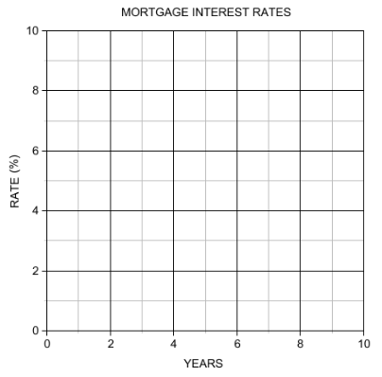

|  |  |  |  |  |  |  |  |  |  |
| --- | --- | --- | --- | --- | --- | --- | --- | --- | --- |
| Year since 2000, *x* | 0 | 1 | 2 | 3 | 4 | 5 | 6 | 7 | 8 |
| Rate (%), *y* | 7.6 | 6.8 | 6.2 | 6.0 | 5.2 | 5.8 | 6.1 | 5.9 | 5.5 |

* 1. Make a scatter plot of the data.
  2. Draw a line of fit.
  3. Write an equation of the line of best fit.
  4. Use the equation to predict the mortgage interest rate

for the year 2010.

* 1. Does the data show a *positive*, a *negative*,

or *no* relationship?

* 1. Interpret the relationship.

1. 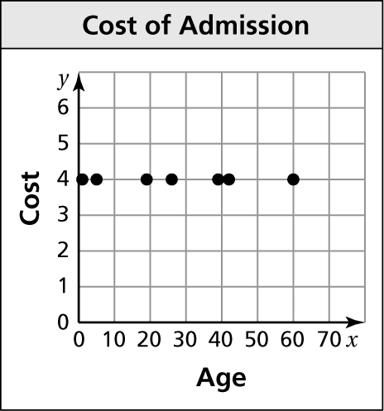The scatter plot shows the relationship between the age of an individual *x* and the cost of admission *y* to a show.
   1. What type of relationship does the data show?
   2. Draw a line of fit.
   3. Write an equation of the line of best fit.
   4. Interpret the relationship.